Chapter 3

Exposing the limitations of molecular machine learning with activity cliffs

3.1 Abstract

Machine learning has become a crucial tool in drug discovery and chemistry at large, e.g., to predict molecular properties, such as bioactivity, with high accuracy. However, activity cliffs – pairs of molecules that are highly similar in their structure but exhibit large differences in potency – have received limited attention for their effect on model performance. Not only are these edge cases informative for molecule discovery and optimization, but models that are well-equipped to accurately predict the potency of activity cliffs have an increased potential for prospective applications. Our work aims to fill the current knowledge gap on best-practice machine learning methods in the presence of activity cliffs. We benchmarked a total of 24 machine and deep learning approaches on curated bioactivity data from 30 macromolecular targets for their performance on activity cliff compounds. While all methods struggled in the presence of activity cliffs, machine learning approaches based on molecular descriptors outperformed more complex deep learning methods. Our findings highlight large case-by-case differences in performance, advocating for (a) the inclusion of dedicated “activity-cliff-centered” metrics during model development and evaluation, and (b) the development of novel algorithms to better predict the properties of activity cliffs. To this end, the methods, metrics, and results of this study have been encapsulated into an open-access benchmarking platform named MoleculeACE (Activity Cliff Estimation). MoleculeACE is designed to steer the community towards addressing the pressing but overlooked limitation of molecular machine learning models posed by activity cliffs.

The work in this chapter has been published as: D. van Tilborg, A. Alenicheva, and F. Grisoni, “Exposing the limitations of molecular machine learning with activity cliffs”, Journal of Chemical Information and Modeling, vol. 62, no. 23, pp. 5938-5951, 2022.

3.2 Introduction

The chemical sciences has seen multiple AI breakthroughs, ranging from computer-assisted synthesis planning^{1–3}, to protein structure prediction^{4,5}, and even de novo molecular design^{6–8}. This AI renaissance^{9–11} has been driven by deep learning – based on neural networks with multiple processing layers (see section 2.4.5)^{12–14}. However, there is currently no consensus on whether deep learning models outperform simpler, “traditional” machine learning approaches (see section 2.4.4) when it comes to molecular property prediction^{15–17}. Since molecular property prediction is still the workhorse of computational drug discovery (and the focus of this thesis), the identification of current gaps in machine learning approaches would allow the development of more reliable and widely applicable models to accelerate molecule discovery.

Molecular property prediction has the principle of similarity at its heart¹⁸ – postulating that similar compounds are likely to have similar properties. Notably, one particular exception to this principle holds great insights into the underlying structure-activity (or structure-property) relationships¹⁹; the activity cliff²⁰.

Activity cliffs are pairs of structurally similar molecules that exhibit a large difference in their biological activity.²⁰

Activity cliffs may cause machine learning models to remarkably mispredict the activity of certain molecules, even with an overall high model predictivity. Although generally constituting a source of “disappointment”²⁰, activity cliffs also encode valuable information for many applications¹⁹ (e.g., hit-to-lead optimization^{21,22}, structural alert development²³), since the large change in activity is induced by small structural changes^{24,25}. Activity cliffs are particularly relevant in the context of virtual screening, with the number of highly similar molecules in commonly used commercial libraries varying between 10,000 and 170,000 (Supp. Table s3.1). While numerous studies have focused on defining activity cliffs^{19,24,26,27}, their detrimental effect on machine learning models has been disproportionately underinvestigated²⁵.
Finally, we argue that models that can provide better predictions on activity cliffs are overall better models, as they capture the underlying “structure-activity landscape”²⁰ more accurately. In other words, we expect that better model performance in the presence of activity cliffs, might translate to overall better model generalization.

Stemming from these considerations, the presented work has a threefold goal: (1) benchmark the performance of several deep learning and traditional machine learning methods on activity cliffs, (2) quantify the effect of activity cliffs on overall model performance, and (3) identify promising approaches and future directions in the field of molecular machine learning. To this end, we compared sixteen traditional machine learning methods – based on human-engineered features (molecular descriptors/fingerprints²⁸) – with six deep learning approaches based on molecular strings or graphs, to predict the biological activity of more than 35,000 molecules over 30 macromolecular targets. In this chapter, we aim to systematically survey the landscape of existing AI approaches for molecular property prediction to identify their limitations and to set the scene for later research. We do this through the lens of activity cliffs as an extreme test case to complement existing benchmarks and datasets^{29–32}, hopefully capturing modeling deficiencies more realistically.³³

3.3 Study design

Bioactivity data
To ensure a comprehensive analysis of model performance, we collected and curated data on 30 macromolecular targets from ChEMBL³⁴ v29 (Table 1). Acknowledging the limitations of public data, we tried to rule out the presence of significant sources of error as much as possible, by curating molecules considering best practices^{35–37}. In particular, we checked for (a) the presence of duplicates, salts, and mixtures, (b) the consistency of structural annotations (i.e., molecular validity and “sanity”, charge standardization, and stereochemistry definition), and (c) the reliability of the reported experimental values in terms of annotated validity, standard deviation of multiple entries, and presence of outliers (see Materials and Methods). The curated collection contains a total of 48,707 molecules (of which 35,632 were unique) and mimics typical drug discovery datasets, as it: (a) includes several target families relevant for drug discovery (e.g., kinases, nuclear receptors, G-protein-coupled receptors, transferases, and proteases), and (b) spans different training scenarios, from small (e.g., 615 molecules for Janus Kinase 1, JAK1) to large (e.g., 3657 molecules, dopamine D3 receptor, DRD3) datasets (Table 3.1).

Table 3.1 | Dataset overview, with response type (inhibition [inhibitory constant, K_{i}] or agonism [half maximal effective concentration, EC₅₀]), the number of total and test set molecules (n and n_{TEST}, respectively), along with the percentage of total and test activity cliffs (%cliff and %cliff_{test}). An extensive description of the datasets can be found in Supp. Table S3.2.
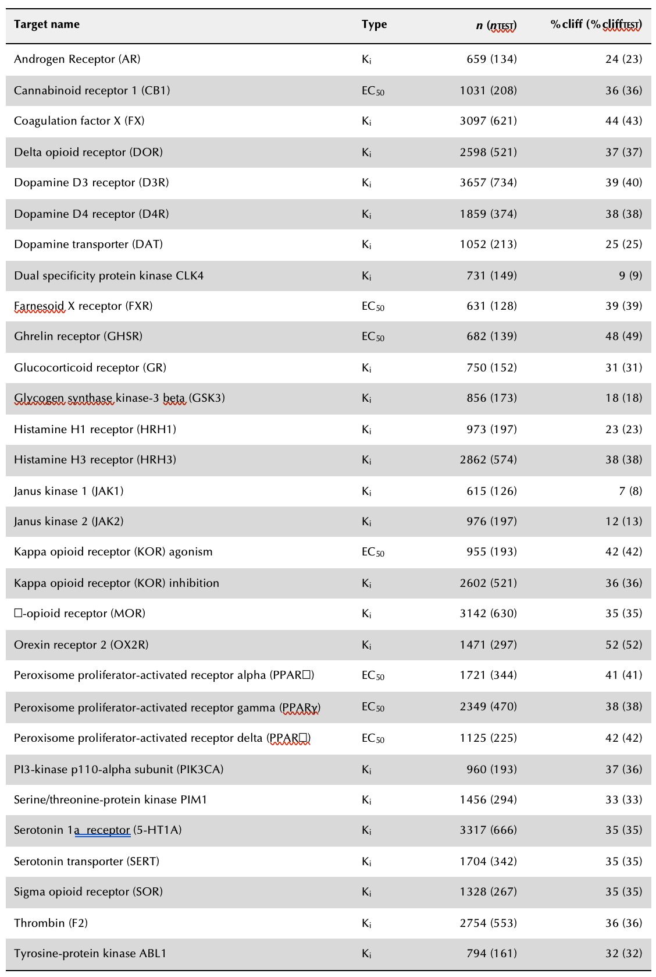

Activity cliff definition
For each macromolecular target, activity cliffs were identified by considering pairwise structural similarity and differences in potency. We quantified molecular similarity between any pairs of molecules belonging to the same dataset with three distinct approaches:
- Substructure similarity. We computed the Tanimoto coefficient³⁸ on extended connectivity fingerprints³⁹ (ECFPs), to capture the presence of shared radial, atom-centered substructures among pairs of molecules. This approach captures “global” differences between molecules by considering the entire set of substructures they contain (Fig. 3.1a).
- Scaffold similarity, determined by computing ECFPs on atomic scaffolds⁴⁰ and calculating the respective Tanimoto similarity coefficient. Including scaffold similarity allows identifying pairs of compounds that have minor differences in their molecular cores or differ based on their scaffold decoration (Fig. 3.1b).
- Similarity of SMILES strings, captured by using the Levenshtein distance⁴¹. This metric detects character insertions, deletions, and translocations (Fig. 3.1c).

Although there is no widely accepted definition of activity cliffs^{19,42,43} and each similarity metric captures only part of the underlying ‘chemical reality’, these three definitions were chosen to cover different types of structural differences relevant to medicinal chemistry. Moreover, they are in line with existing literature on activity cliffs (Supp. Table s3.3). We currently don’t account for chirality cliffs since many descriptors cannot encode stereochemistry. Pairs of molecules that had a computed similarity larger than 90% with at least one of the three methods were considered as ‘highly similar’ in structure. We specifically use a ‘soft’ consensus to retain the unique properties the different similarity measures capture (e.g., fragment translocation which is only captured well by SMILES similarity). Such pairs of compounds were then checked for their difference in reported potency. In agreement with previous studies²¹, a one-fold (10x) or larger difference in bioactivity (i.e., on reported K_{i} or EC₅₀ values) was used to identify activity cliff pairs.

To qualify as an activity cliff, a pair of molecules must:
- Have a similarity of 90% or higher with at least one of three similarity methods (substructure, scaffold, or SMILES string similarity).
- Have a one-fold (10x) or larger difference in bioactivity.

Compounds in our datasets that formed at least one activity cliff pair were labeled as “activity cliff compounds”. The percentage of activity cliff compounds identified with our approach varied from 7% (JAK1) to 52% (OX2R, Table 3.1). We consider our definition a balanced and well-rounded approach to activity cliffs. For example, a stricter two-fold (100x) potency difference reduced the mean number of activity cliff compounds in our test sets from 116 ± 79 to 26 ± 21 (with only one compound for JAK1 in the most extreme case), making the evaluation of their effects on performance limited. Also, although widespread in their usage, we did not consider matched molecular pairs^{43,44}, as they almost doubled the number of cliff compounds compared to our initial approach, while covering 86.6% of cliff compounds identified by our approach.
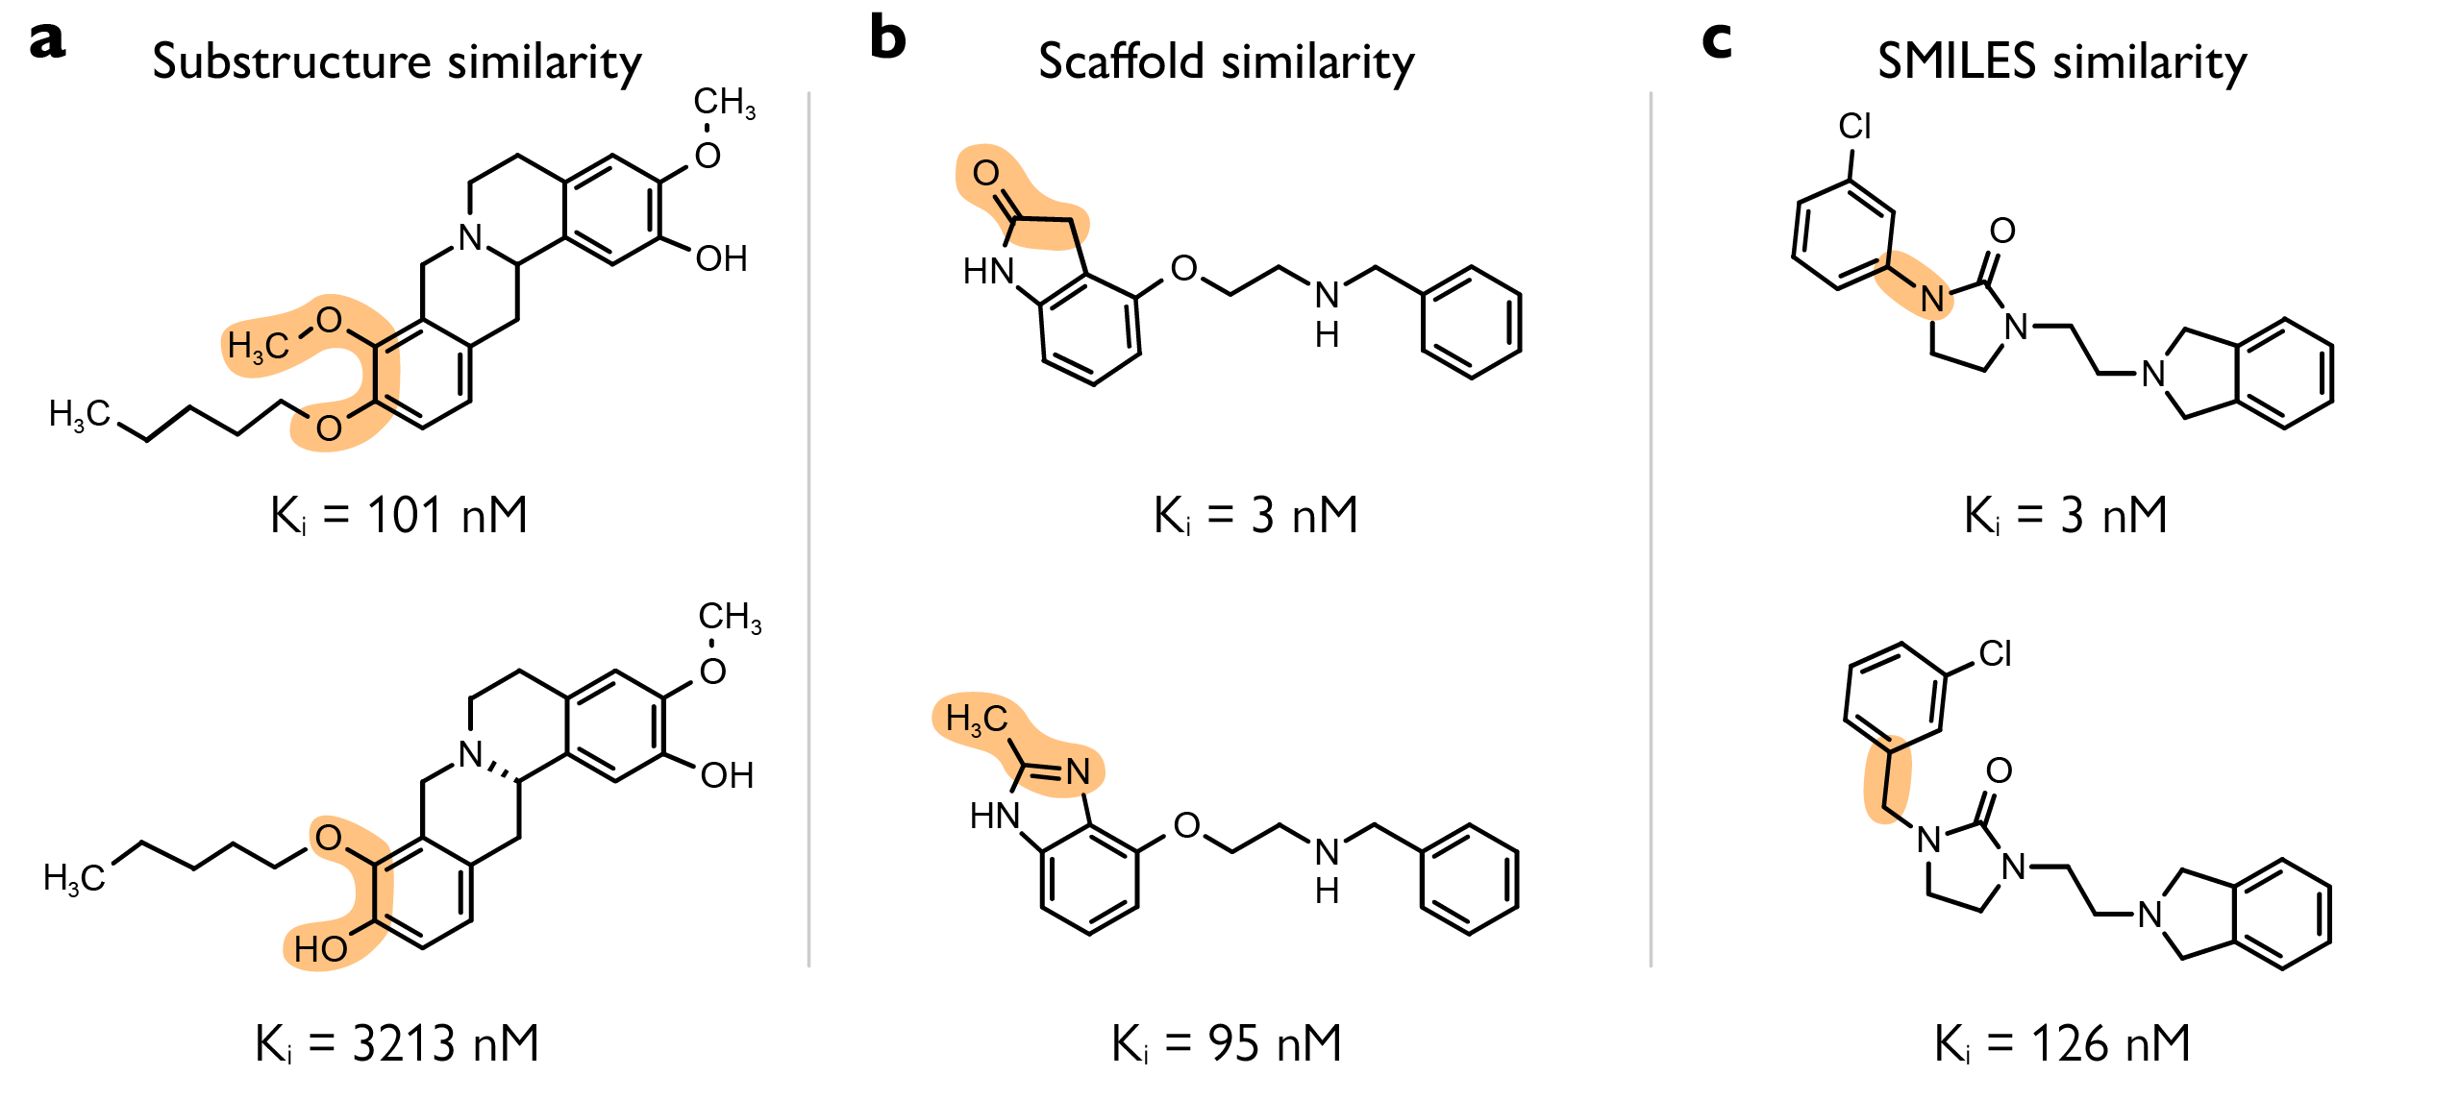
Fig. 1 | Selected examples of activity cliffs (on Dopamine D3 receptor, D3R). a, General substructure similarity (Tanimoto coefficient on ECFP). b, Scaffold similarity that quantifies the similarity between molecular cores or scaffold decorations (Tanimoto coefficient on scaffold ECFP). c, SMILES similarity which detects string insertions, deletions, and translocations (scaled Levenshtein distance).

Data splitting strategy
The nature of activity cliffs complicates data splitting into training and test sets. Having high structural similarity, but vastly differing bioactivities, makes it infeasible to evenly distribute activity cliff molecules across sets by both their structure and activity. Besides, multiple molecules are often involved in the same activity cliff series: across all datasets, molecules have on average 2.7 ± 0.9 activity cliff ‘partners’ identified by our approach (Supp. Table s3.4). In this work, we set out to ensure (a) proportional representation of the number of activity cliff compounds in the train and test set (to avoid an over/underestimation of their effect on the performance), and (b) preserving structural similarity between training and test molecules, as previously suggested⁴⁵.

To this end, for each dataset, molecules were clustered based on substructure similarity, using spectral clustering⁴⁶ on extended connectivity fingerprints (ECFPs)³⁹. For each cluster, molecules were split into a training (80%) and test set (20%) by stratified random sampling, using their activity cliff label (see Materials and Methods). This method ensured that, even in the case where all activity cliff ‘partners’ end up in the test set (9.1 ± 5.3% of activity cliff molecules on average), highly similar molecules (in terms of substructure [0.80 ± 0.03], scaffold [0.93 ± 0.02], and SMILES [0.95 ± 0.01] similarity) are still present in the training set (Supp. Table S3.4).

To rule out any potential bias in favor of ECFPs, we set out to compare the similarities of different molecular descriptors/fingerprints in the training and test set, for each macromolecular target (see Materials and Methods). An FDR-adjusted Mann-Whitney-U test (α = 0.05) revealed no statistical difference between the distributions of the two sets across all descriptors/fingerprints and all targets. This indicates that the train-test similarity is preserved also when using different molecular descriptors.

Modeling approaches
In this work, we considered four traditional machine learning algorithms that are commonly used for structure-activity relationships prediction (Fig. 2.4c), each coupled with four types of molecular descriptors/fingerprints²⁸, spanning several levels of complexity (Fig. 2.3).

Traditional machine learning algorithms:
- K-nearest neighbor (KNN), which is expected to struggle with activity cliffs since it operates directly on similarity and acts as a baseline.⁵¹
- Random forest (RF).⁵²
- Gradient boosting machine (GBM).⁵³
- Support vector regression (SVM).⁵⁴

Molecular descriptors/fingerprints:
- Extended connectivity fingerprints (ECFPs), a ‘golden standard’.⁴³
- Molecular ACCess System keys (MACCs).⁵⁵
- Weighted Holistic Invariant Molecular (WHIM) descriptors.⁵⁶
- 11 physicochemical properties relevant for drug-likeness (see Materials and Methods) that act as a baseline.⁵⁷

Although this selection is not comprehensive and could be expanded (especially owing to the high number of existing molecular descriptors²⁸), we consider it a good overview of methods used in the medicinal chemistry domain.
Opposing the traditional machine learning methods, we considered eight deep learning algorithms (Fig. 2.4d-f). Since neural networks that can learn directly from molecular graphs are becoming increasingly popular for molecular property prediction^{14,47–50}, we explored four graph neural network architectures. Additionally we employed three sequence modeling approaches operating on SMILES strings⁵¹, popular for de novo molecular design^{6–8}. Finally, we included a simple neural network coupled with ECFPs.

Graph neural networks:
- Message passing neural network (MPNN).⁶²
- Graph attention network (GAT).⁶³
- Graph convolutional networks (GCN).⁶⁴
- Attentive fingerprint (AFP), which uses attention mechanisms at both the atom and molecule level, allowing it to better capture subtle substructure patterns.⁵⁹

Sequence modeling:
- Convolutional neural networks (CNN).⁶⁶
- Long short-term memory (LSTM) networks.⁶⁷ As in a previous study⁶⁸, LSTM models were pre-trained using next-character prediction on SMILES obtained by merging all training sets with no repetitions (36,281 molecules), before applying transfer learning for bioactivity prediction.
- Transformer model. The pre-trained ChemBERTa⁷⁰ architecture (10M compounds) was used in combination with transfer learning for bioactivity prediction.

Fingerprint modeling:
- Multi-layer perceptron (MLP).

In agreement with previous studies^{52–54}, we used 10-fold SMILES augmentation (Fig. 2.5a) to artificially increase the number of training samples for all approaches.

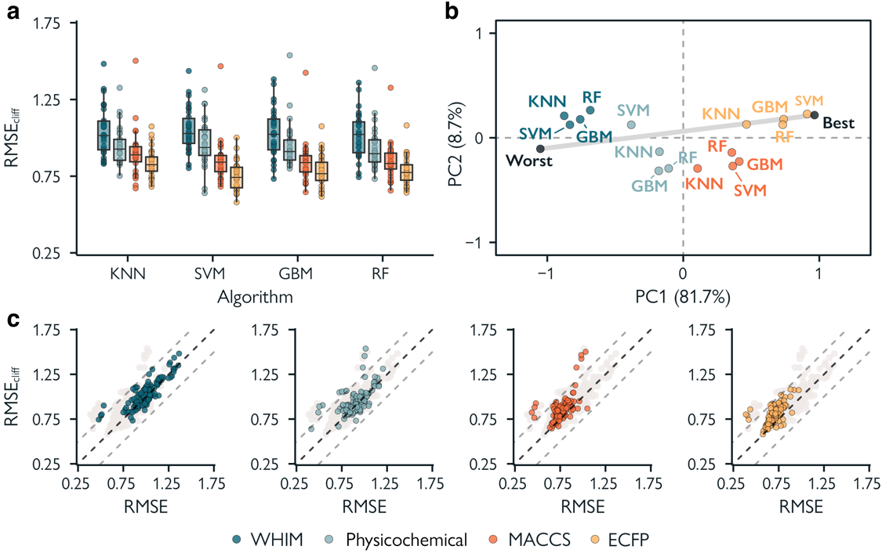
Fig. 3 | Performance of traditional machine learning methods. a, RMSE on activity cliff compounds using different machine learning algorithms and molecular descriptors (indicated by colors). b, Global ranking of all methods using PCA (first two principal components, PC1 and PC2), scaled between best and worst performance. Every point captures the RMSE_{cliff} of a method on all datasets. Percentages represent the variance explained by each principal component. c, Comparison between the error on activity cliff compounds (RMSE_{cliff}) and the error on all compounds (RMSE) for all methods. Black dashed lines indicate RMSE = RMSE_{cliff}, while grey dashed lines indicate a difference of ±0.5 log units between RMSE_{cliff} and RMSE.

Results

3.4.1 Performance of traditional machine learning
First, we evaluated the ability of traditional machine learning approaches to predict bioactivity (expressed as pEC₅₀ or pK_{i}) in the presence of activity cliffs. The performance was quantified using the root mean squared error on test set molecules (RMSE – the lower, the better; Eq. 1) and activity cliff molecules in the test set (RMSE_{cliff} – the lower, the better; Eq. 2).

RMSE: model performance on all molecules in the test set.
RMSE_{cliff}: model performance on all activity cliff molecules in the test set.

Overall, large differences in predictive performance on activity cliff compounds can be observed among datasets, with RMSE_{cliff} values ranging from 0.62 to 1.60 log units (Fig. 3.3a). This effect was also observed on the overall performance of test set molecules, with RMSE values ranging from 0.41 to 1.35 log units (Supp. Fig. s3.1a), in line with previous works^{55–57}. Differences in performance relate mostly to the chosen molecular encoding rather than the machine learning algorithm (p < 0.05, Wilcoxon rank-sum test with Benjamini-Hochberg correction, Supp. Fig. s3.4), with ECFPs yielding the lowest average prediction error on average. Non-binary descriptors (WHIM and physicochemical properties) performed considerably worse overall than binary fingerprints (ECFPs and MACCs), with a higher variation among datasets.

To provide a global assessment of methods across the analyzed datasets, we performed an anchored principal component analysis (PCA) on the obtained RMSE_{cliff} values (Fig. 3.3b and Supp. Fig. s3.2a). PCA is a multivariate analysis technique used for data visualization and dimensionality reduction, which linearly combines the original variables into new orthogonal variables (principal components), sorted by the variance they explain. An anchored PCA ‘anchores’ the variance between the best and worst (highest/lowest) results as in previous studies^{58,59}, enabling a more quantitative interpretation. The closer a method is to the “best” point, the better its overall performance and the higher the orthogonal deviation from the best-worst line, the higher the variability of a method’s performance based on the dataset. For instance, methods based on MACCS fingerprints show a higher dependency on the chosen targets than those based on ECFPs. KNN methods show the highest dependency on the chosen target overall.

Our analysis confirms that molecular encodings impact performance more than the chosen machine learning algorithm^{60,61}. SVM coupled with ECFPs resulted in the best method on activity cliffs on average, in agreement with a previous study⁶². However, no statistical difference was found between SVM, GBM, or RF coupled with ECFPs (Wilcoxon rank-sum test, Supp. Fig. s3.4). In the case of our results, however, the superior performance of ECFPs is somewhat surprising, given that the definition of activity cliffs heavily depends on them (criteria 1 and 2, Fig. 3.1a), which was expected to introduce an unfavorable bias.

To further investigate the relevance of considering activity cliffs for model assessment, we compared RMSE_{cliff} with the overall error on the test set molecules (Fig. 3.3c and Supp. Fig. s3.3). As expected, activity cliff compounds tend to yield higher prediction errors, regardless of the considered approach⁶³. Although in most of the cases RMSE and RMSE_{cliff} are highly correlated (r = 0.81 on average), the model performance on activity cliff compounds might be overestimated when considering RMSE alone, up to 0.54 log units. For instance, SVM coupled with ECFP descriptors – resulting in the best performance on average – ranged greatly in its ability to handle activity cliffs. While the mean difference between RMSE and RMSE_{cliff} for this method was only 0.094 log units, large differences were observed in certain data sets (e.g., up to 0.39 log units for the JAK1 receptor). This underscores that strategies with a low overall prediction error might not necessarily be the best ones at handling activity cliffs, thereby hampering their potential for prospective applications.

3.4.2 Performance of deep learning methods
Deep learning approaches were trained on either molecular graphs, SMILES strings, or ECFPs (Fig. 3.4a). The best performing traditional machine learning method (SVM with ECFP fingerprints), is included in this section as a reference point. Transfer learning⁶⁴ (see Fig. 2.5b) was applied to the LSTM and transformer models in agreement with previous studies^{65–68}. In a preliminary analysis, we explored transfer learning approaches for graph neural networks using self-supervision (context prediction⁶⁹, infomax⁷⁰, edge prediction⁷¹, and masking⁶⁹). Since no approach yielded a notable increase in predictive performance (in line with a recent study⁷²), we did not consider transfer learning further for graph neural networks.

When comparing the performance of all tested deep learning methods, we found large differences in predictive performance across datasets – similar to traditional machine learning approaches – with RMSE_{cliff} values ranging from 0.68 to 1.44 log units (Fig. 3.4a). Among the graph-based neural networks, MPNN models resulted in the lowest error on activity cliff compounds on average, although no differences were statistically significant (Wilcoxon rank-sum test with Benjamini-Hochberg correction, Supp. Fig. s3.4). SMILES-based methods outperformed graph-based methods on average, with LSTM models outperforming all other deep learning methods, including the SMILES-based CNN and transformer models. For CNNs, we did not implement any transfer learning strategy, which could explain their poor(er) performance compared to the other SMILES-based methods. Notably, despite transformers were pretrained on a larger corpus of SMILES strings than LSTMs (10M compounds⁶⁶ versus 36,281 molecules), they did not perform better.
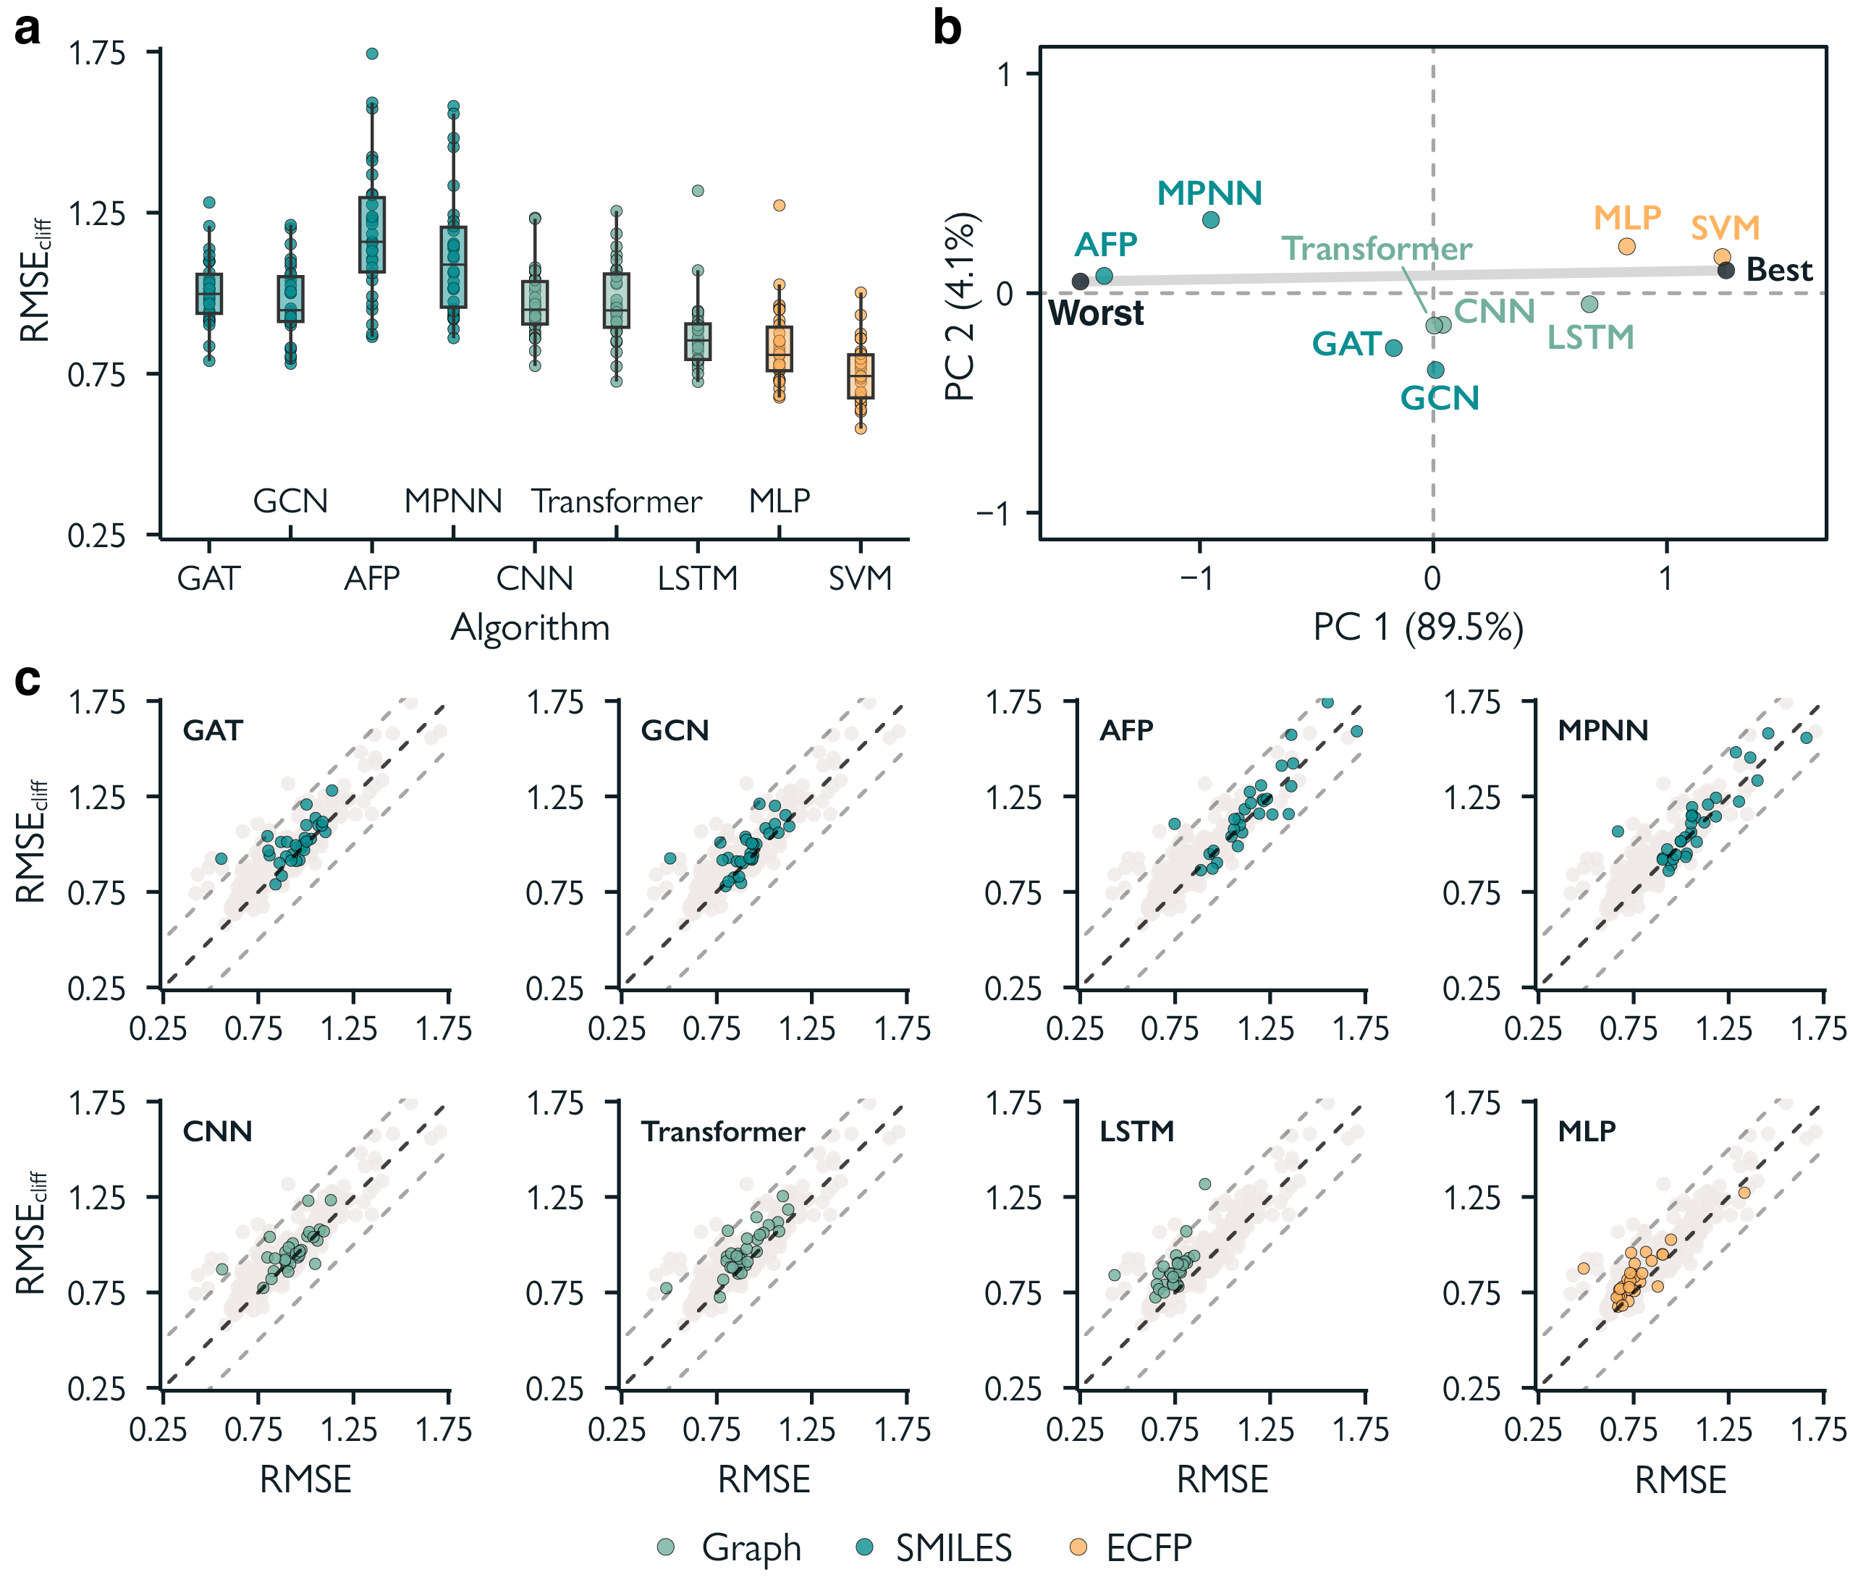Fig. 4 | Performance of deep learning methods. a, RMSE on activity cliff compounds on different deep learning strategies. SVM is reported as a reference. b, Global ranking of all methods using PCA (first two principal components, PC1 and PC2), scaled between best and worst performance. Percentages indicate the explained variance by each principal component. c, Prediction error on activity cliff compounds (RMSE_{cliff}) compared to all compounds (RMSE) for all methods.

When inspecting the anchored PCA performed on the obtained RMSE_{cliff} values for each target (Fig. 4b), the multi-layer perceptron coupled with ECFPs outperformed all other neural networks based on SMILES or graphs. This is surprising to a certain extent, considering that both ECFPs and SMILES are constructed from a molecular graph. This aspect further underscores a current gap in learning efficient features from ‘raw’ molecular representations in the small data regimes typical of drug discovery. Compared to most traditional machine learning approach, deep neural networks seem to fall short at picking up subtle structural differences (and the corresponding property change) that give rise to activity cliffs. Similar results were obtained when comparing graph networks for (a) feature attribution with activity cliffs⁷³, and (b) bioactivity prediction²⁹. A recent analysis on physicochemical-property cliffs highlights an opposite trend, with deep learning methods performing better than simpler machine learning approaches⁷⁴ – potentially due to the higher number of training samples (approx. 20,000 molecules).

Interestingly, no deep learning method was stable across datasets, as shown by the large deviation from the worst-best line (Fig. 3.4b and Supp. Fig. 3.2b). This highlights the need of evaluating the usage of such methods on a case-by-case basis.

3.4.3 Failure modes of machine learning on activity cliffs.
The systematic training and assessment of 720 machine learning models allowed us to investigate the potential “failure modes” of machine learning approaches on activity cliffs. In general, all methods tend to struggle in the presence of activity cliffs (Fig. 3.3 and Fig. 3.4). Our first analysis addressed the variation of RMSE_{cliff} across methods and datasets, in search of causes of poor performance. Although small-data regimes are known to affect the performance of machine- and deep-learning methods, no correlation was found between the number of molecules in the training set and the prediction error on activity cliffs (Supp. Fig. s3.5a). Furthermore, no relationship between the percentage of activity cliff compounds in the data and model performance was found, except for differences between RMSE and RMSE_{cliff}. This relates to the fact that, the higher the percentage of activity cliffs, the more the RMSE_{cliff} values (computed on a subset of molecules, Eq. 2) will approach RMSE values (Supp. Fig. s3.5d). At the same time, the drug target family did not seem to affect RMSE_{cliff} either (Supp. Fig. s3.5e), further highlighting the difficulties in forecasting the performance of machine learning on activity cliffs.

We then compared the overall prediction error (RMSE on test set molecules) with the performance on activity cliffs (RMSE_{cliff} on test set molecules). While RMSE and RMSE_{cliff} tend to correlate to a high degree (r > 0.70 for 25 datasets out of 30, Fig. 3.5a), we observed large case-by-case variations. In most cases, the difference between RMSE_{cliff} and RMSE is similar among methods (Fig. 3.5a, b). This implies that, when choosing a method for its overall error on test set molecules, the performance on activity cliff compounds will be implicitly accounted for. However, for some targets (e.g., CLK4), methods with comparable RMSE scores can exhibit large differences in RMSE_{cliff} scores (Fig. 3.5c). This indicates that, in these specific cases, choosing a model based on RMSE only might lead to poor prospective performance, e.g., for hit-to-lead optimization or virtual screening in the presence of congeneric compounds (Supp. Table s3.1). These ''islands'' of poor performance on activity cliffs were observed across the whole spectrum of machine learning strategies, independently of the reported average performance.

To better elucidate the “drivers of failure” on activity cliffs, we investigated the effect of the training set size on (a) the difference between predictive performance on the entire test set and on activity cliffs only (RMSE_{cliff} - RMSE) and (b) the correlation between the overall performance (RMSE) and the performance on activity cliffs (RMSE_{cliff}). The absolute difference between RMSE and RMSE_{cliff} does not correlate with the number of training molecules (r = -0.15, Fig 3.5d). However, the number of training molecules is an important factor in determining the correlations between RMSE and RMSE_{cliff} (Fig. 3.5e). Datasets containing enough training molecules (e.g., larger than 1000) showed a high correlation between RMSE and RMSE_{cliff} (r > 0.80). In other words, if the number of training molecules increases, the “relative difficulty” of predicting bioactivity on activity cliff molecules decreases. This implies that, with sufficient training molecules, optimizing RMSE alone will implicitly optimize RMSE_{cliff}, too. However, the problem of determining the targets on which RMSE_{cliff} will be suboptimal (the “islands” of poor performance) remains. This underscores the relevance of implementing activity-cliff-related evaluation approaches, especially in small data regimes. Moreover, these results corroborate the need to develop more efficient machine and deep learning models for low-data regimes.

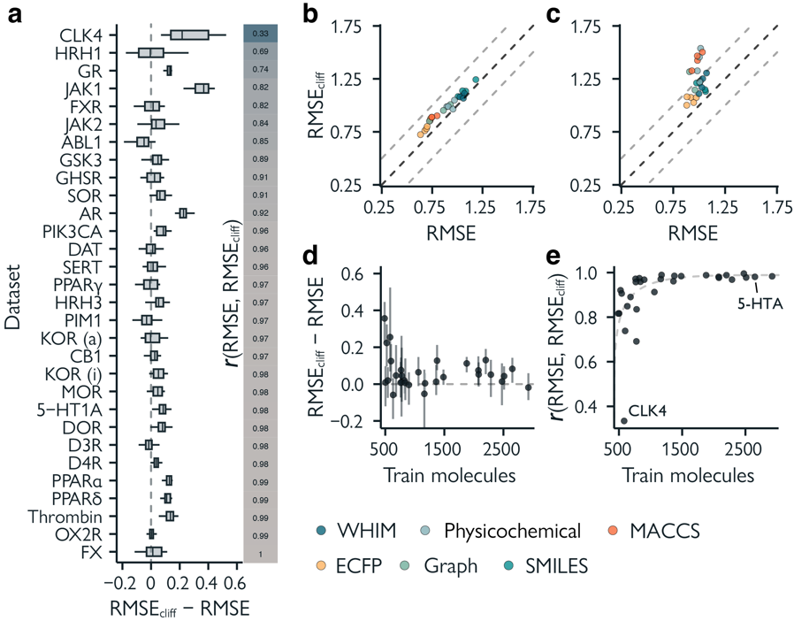
Fig. 5 | Comparing overall model performance and performance on activity cliff compounds. a, Method-wide differences between overall RMSE and RMSE_{cliff} for all targets ordered by Pearson correlation (r) between RMSE and RMSE_{cliff}. Error bars indicate lowest and highest RMSE_{cliff}. b, Comparison between RMSE and RMSE_{cliff} of all methods on 5-HT1A. c, Comparison between RMSE and RMSE_{cliff} of all methods on CLK4. d, Effect of the number of training molecules on the difference between RMSE and RMSE_{cliff}. Error bars indicate lowest and highest RMSE_{cliff}. e, Relationship between the number of training molecules and the Pearson correlation (r) of RMSE and RMSE_{cliff}.

3.4.4 An activity-cliff centered benchmark
Our results and systematic analysis expose current limitations of molecular machine learning and motivate the use of dedicated metrics and tools for assessing the model performance on activity cliffs, especially in low data regimes. Hence, we collected the modeling and assessment strategies of this study into a dedicated, “activity-cliff-centered” benchmark tool, called MoleculeACE (available at URL: https://github.com/molML/MoleculeACE). All datasets and scripts to replicate this study can be found here as well. MoleculeACE integrates standardized data processing for molecular bioactivity data, a comprehensive approach to quantifying activity cliffs, and the tailored performance evaluation strategies presented in this work.

Thanks to its modular character, MoleculeACE will allow researchers to:
- Systematically benchmark a model’s performance on activity cliffs compounds, in comparison with well-established machine- and deep learning methods.
- Evaluate the deck of chosen models on a new dataset not included in our benchmark, thanks to the data collection and curation pipeline.
- Further expand the definition of activity cliffs^{27,75,76}, based on specific use cases¹⁹. It is possible to use custom thresholds for potency differences and structural similarity (e.g., matched molecular pairs, which are already supported) in determining cliff compounds. As this work relies on public bioactivity data, which might be affected by undetectable experimental noise^{63,77} (despite the best data curation efforts), we hope in the future to also see applications of MoleculeACE on more homogeneous data, e.g., in terms of used in vitro assay and assay conditions.

We hope that MoleculeACE, along with the results of this benchmark study, will incentivize machine learning researchers to consider the crucial topic of activity cliffs in model evaluation and development pipelines. We envision that MoleculeACE will serve as a platform for the wider community to develop models that can more accurately capture complex structure-activity landscapes — and ultimately boost the capabilities of machine learning for molecule discovery.

3.5 Discussion

While machine learning is increasingly often employed for early drug discovery, the topic of activity cliffs has found only limited attention by the scientific community. As shown by our results, not only do machine learning strategies struggle with activity cliffs compared to their overall performance but deep learning methods are particularly challenged by the presence of such compounds. Approaches based on human-engineered molecular descriptors/fingerprints resulted to outperform deep learning based on graphs or SMILES, with no machine learning strategy being consistently better at handling activity cliffs compared to their absolute performance. Our results corroborate previous evidence showing that deep learning methods do not necessarily hold up against simpler machine learning methods (yet) for drug discovery purposes^{15–17}. Although our analysis does not allow us to identify the principal cause of the performance gap of activity cliff molecules found across all methods, we speculate that current molecular representations and corresponding representation learning algorithms might not capture complex structure-activity information well enough, particularly due to the high non-additivity present in the data^{78,79}. We envision the development of deep learning strategies that are (a) more efficient in low-data scenarios, like semi- or self-supervised learning⁸⁰ and (b) better suited to capture structure-activity “discontinuities” to be key for future prospective applications. Structure-based deep learning approaches^{81–83} (considering the structure of the macromolecular target in addition to ligand information) might be key to filling current performance gaps caused by activity cliffs. However, to date, there is no consensus on the benefit of including structural information into machine learning for bioactivity prediction⁸⁴, potentially due to undesirable bias in existing databases^{84–86}.

In the framework of our study design, the model’s performance on activity cliff compounds resulted to be highly dataset-dependent, especially for deep learning methods in low-data scenarios. Although the overall prediction error often approximates the performance on activity cliffs, “islands” of poor performance on activity cliffs exist when different strategies are compared on the same data set. These results highlight the importance of evaluating machine learning models for their performance on activity cliffs, especially when prospective applications are envisioned (e.g., virtual screening)⁸⁷.

To facilitate such an “activity cliff-centered” model evaluation and development, we developed MoleculeACE. By estimating a model’s performance in the presence of activity cliffs alongside regular performance, MoleculeACE has the goal of incentivizing researchers in molecular machine learning to consider the long-standing issue of activity cliffs fully. Models that can accurately predict the effects of subtle structural changes on molecular properties will ultimately give rise to more effective hit-to-lead optimization and the identification of activity cliffs during lead optimization. We envision these improvements as key to propelling the potential of deep learning in drug discovery and beyond.

3.6 Materials and Methods

Data curation
Data collection and preparation. For each macromolecular target, compound bioactivity values were collected from ChEMBL³⁴ v29 via the ‘ChEMBL webresource’ client (Homo sapiens). Molecules in the form of canonical SMILES strings were sanitized using RDKit⁸⁸ v. 2020.09.5 with default settings and neutralized if charged. Compounds with failed sanitization, annotated in the form of salts, and/or with doubtful data validity (as in the “data_validity_comment” entry of ChEMBL) were removed (4.74% on average). For each unique SMILES string, experimental bioactivity data (i.e., K_{i} or EC₅₀ values [nM]) were collected. Dixon’s Q test⁸⁹ was used to detect the presence of outliers among multiple annotations of a given molecule (α = 0.05, 0.78% of molecules on average). The mean K_{i} or EC₅₀ value for each molecule was computed and subsequently converted into pEC₅₀/pK_{i} values (as the negative logarithm of molar concentrations). If the standard deviation of the multiple annotations used to compute the average was above 1 log unit, the corresponding molecule was removed (4.33% on average). To rule out errors due to inconsistent annotation of stereochemistry, pairs of compounds having different canonical SMILES but identical ECFPs were removed (9.74% on average).

Molecular descriptors calculation. Molecular descriptors were computed from canonicalized SMILES strings using RDkit v. 2020.09.5⁸⁸. (a) Extended Connectivity Fingerprints (ECFP)³⁹ were computed with a length of 1024 bits and a radius of 2 bonds. (b) MACCS keys⁹⁰ with a length of 166, were computed with default settings. (c) Weighted Holistic Invariant Molecular (WHIM) descriptors⁹¹ (114 descriptors), were computed on the minimum energy conformers generated with experimental-torsion knowledge distance geometry⁹² and MMFF94⁹³ force field optimization. (d) “Physico-chemical descriptors'' included 11 properties of drug-likeness, i.e., molecular weight, predicted octanol-water partitioning coefficient⁹⁴, molar refractivity, topological polar surface area, formal charge, and the number of hydrogen bond donors, hydrogen bond acceptors, rotatable bonds, atoms, rings, and heavy atoms. Real-valued descriptors were standardized by gaussian normalization using the training data mean and standard deviation values.

Detection of activity cliffs. Pairs of structurally similar molecules were detected with three approaches: (a) substructure similarity, computed via the Tanimoto coefficient on ECFP; (b) scaffold similarity, calculated on the ECFP of molecular graph frameworks⁴⁰ (Tanimoto coefficient); (c) (canonical) SMILES similarity, computed using the Levenshtein distance^{41,95} (scaled and subsequently converted into ‘1-distance’). Pairs of compounds having a computed similarity equal to or larger than 0.9 according to at least one of these metrics were checked for the fold-difference in their respective bioactivity (in nM units). Pairs of highly similar compounds showing more than a 10-fold difference in their respective bioactivity were considered activity cliffs.

Train/test splitting. For each target, molecules were clustered by their molecular structure (described as ECFP) into five clusters using spectral clustering⁴⁶ implemented with sklearn v. 1.0.2⁹⁶ (using a Gaussian kernel and a precomputed affinity matrix of Tanimoto distances). For each cluster, 80% of molecules were assigned to the training data, and 20% to the test data, by stratified splitting (using their belonging to at least one activity cliff pair [‘yes’/’no’] as a label).

Descriptor similarity between training and test sets. Similarity among molecular descriptors in the training set was calculated as the mean distance of each molecule in the train set to its five nearest neighbors in the train set. Similarity between molecular descriptors of each molecule in the test set was calculated for the five nearest neighbors in the train set. Graph representations were not considered, as computing graph distances is non-trivial and ECFPs are directly related to molecular graphs. A Mann-Withney U test, corrected for a false discovery rate of 0.05, was performed using SciPy v. 1.8.1⁹⁷.

Molecular graph featurization. For all methods, atom features were encoded as follows. (a) One-hot-encoded properties: atom type, orbital hybridization, atomic vertex degree, aromaticity, and ring membership. (b) Numerically-encoded properties: atomic weight, partial charge (Gasteiger-Marsili⁹⁸), number of valence electrons, and number of bound hydrogens. Atomic weight and partial charge were scale-transformed via a sigmoidal function. For MPNN and AFP architectures, bond features were included, i.e., with bond type and conjugation (one-hot encoded).

Model implementation
Hyperparameter optimization. Hyperparameter optimization was performed with Bayesian optimization using a Gaussian process (method-based specifics are mentioned below). For all models, a maximum of 50 hyperparameter combinations were evaluated, using five-fold cross validation.

Traditional machine learning algorithms. KNN, SVM, GBM, and RF regression models were implemented using sklearn v. 1.0.2⁹⁶. For each approach, the model hyperparameters were optimized as follows: (a) KNN, optimization of the number of neighbors (k), k = [3, 5, 11, 21]; (b) SVM, optimization of kernel coefficient (γ) and regularization parameter (C), γ = [1x10⁻⁶, 1x10⁻⁵, 1x10⁻⁴, 1x10⁻³, 1x10⁻², or 1x10⁻¹] and C = [1, 10, 100, 1000, 10000]; (c) GBM, optimization of number of boosting stages (n_{b}) and maximal model depth (m_{d}), n_{b}= [100, 200, 400] and m_{d} = [5, 6, 7]; (d) RF, number of decision trees (t), t = [100, 250, 500, 1000].

Graph neural networks. All regression models were implemented using the PyTorch Geometric package v. 2.0.4⁹⁹. In MPNN, GCN, and GAT models, global pooling was implemented with a graph multiset transformer¹⁰⁰ using eight attention heads, followed by a fully connected prediction head. For all models, we optimized the learning rate (lr), lr = [5x10⁻⁴, 5x10⁻⁵, or 5x10⁻⁶]. The following hyperparameters were optimized: (a) GCN, hidden atom features (h_{a}), number of convolutional layers (n_{c}), hidden multiset transformer nodes (h_{t}), hidden predictor features (h_{p}), , h_{a} = [32, 64, 128, 256, 512], n_{c} = [1, 2, 3, 4, 5], h_{t} = [64, 128, 256, 512], h_{p} = [128, 256, 512]; (b) GAT, the hyperparameter search space used for GCN models and the use of GATv1¹⁰¹ or GATv2¹⁰² convolutions; (c) MPNN, hidden atom features (h_{a}), hidden edge features (h_{e}), number of message passing steps (s_{m}), , hidden multiset transformer nodes (h_{t}), hidden predictor features (h_{p}), h_{a} = [32, 64, 128, 256], h_{e} = [32, 64, 128, 256], s_{m} = [1 ,2 ,3, 4, 5], h = [64, 128, 256, 512], h_{p} = [128, 256, 512]; (d) AFP, number of attentive layers (n_{a}), timesteps (n_{t}), number of hidden predictor features (h_{p}), n_{a} = [1, 2, 3, 4, 5], n_{t} = [1, 2, 3, 4, 5], h_{p} = [32, 64, 128, 256]. All models were trained for 300 epochs, using early-stopping with a patience of 10 epochs.

Feed-forward neural network. A multi-layer perceptron was implemented using Pytorch v. 1.11.0¹⁰³. It was optimized for: (a) learning rate (lr = [5x10⁻⁴, 5x10⁻⁵ 64, 5x10⁻⁶]), (b) number of hidden features (n_{h} = [256, 512, 1024]) and (c) number of layers (n_{l}) = [1, 2, 3, 4, 5]. Models were trained for 500 epochs using early stopping with a patience of 10 epochs.

SMILES-based models. SMILES strings were encoded as one-hot vectors. SMILES strings longer than 200 characters were truncated (0.71% on average). 10-fold data augmentation was applied to all SMILES-based methods using a maximum of 9 extra non-canonical SMILES strings for every SMILES string in the data set. Non-canonical SMILES strings were generated using RDKit⁸⁸.
(a) LSTM models were pre-trained on SMILES obtained by merging all training sets with no repetitions (36,281 molecules), using next-character prediction as in a recent study⁶⁵. The network was composed of four layers comprising 5,820,515 parameters (layer 1: batch normalization; layer 2: LSTM with 1024 units; layer 3: LSTM with 256 units; layer 4: batch normalization). We used the Adam optimizer with a learning rate of 10⁻⁴ for 100 epochs. Regression models were then obtained by transfer learning (with weight freezing for layer no. 2) for 100 epochs with a regression head.
(b) 1D CNNs were adapted from a recent study⁵². We used a single 1D convolutional layer with a stepsize equal to 1, followed by a fully connected layer, with training for 500 epochs. It was optimized for the learning rate (lr), number of hidden features in the fully connected layer (n_{h}), and convolution kernel size (n_{k}), lr = [5x10⁻⁴, 5x10⁻⁵ 64, 5x10⁻⁶], n_{h} = [128, 256, 512, 1024], n_{k} = [4, 8, 10]. (c) Transformer models and the corresponding SMILES tokenization were based on the ChemBERTa⁶⁶ architecture. We used the pre-trained ChemBERTa model weights based on 10M compounds from PubChem¹⁰⁴. We fine-tuned the model by freezing its weights and replacing the final pooling layer by a regression head with 1 fully connected layer, and trained for 100 epochs. We used the Adam optimizer with a learning rate of 5x10⁻⁴. For all methods, we used early stopping with a patience of 10 epochs.

Performance evaluation. The overall model performance was quantified via the root mean square error (RMSE) computed on the bioactivity values (i.e., pK_{i} or pEC₅₀), as follows (Eq. 1):
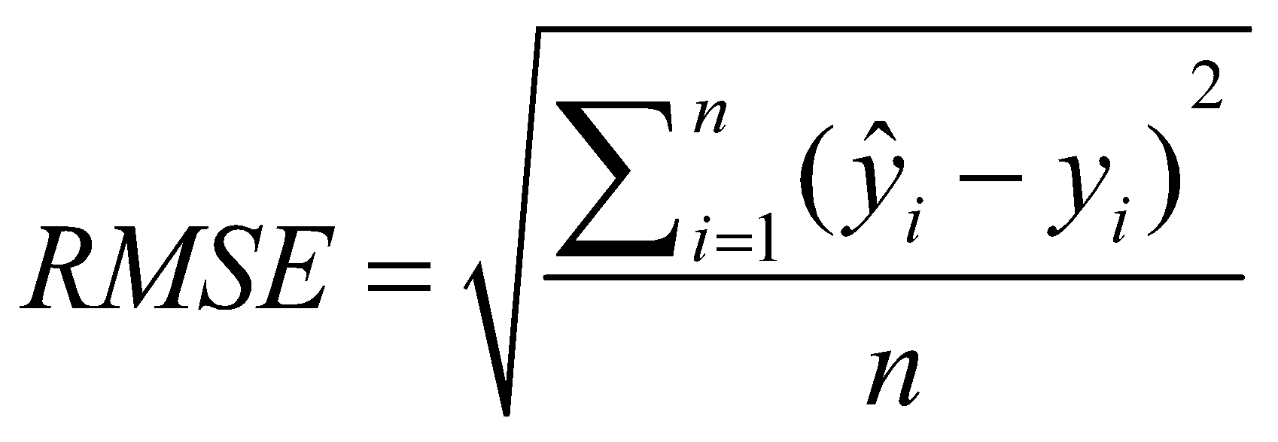 | (1)
where${\hat{ y}}_{i}$is the predicted bioactivity of the i-th compound and $y_{i}$ is the corresponding experimental value, while n represents the number of considered molecules.

The performance on activity cliffs compounds was quantified by computing the root mean square error (RMSE_{cliff}) only on compounds that belonged to at least one activity cliff pair, as follows (Eq.2):
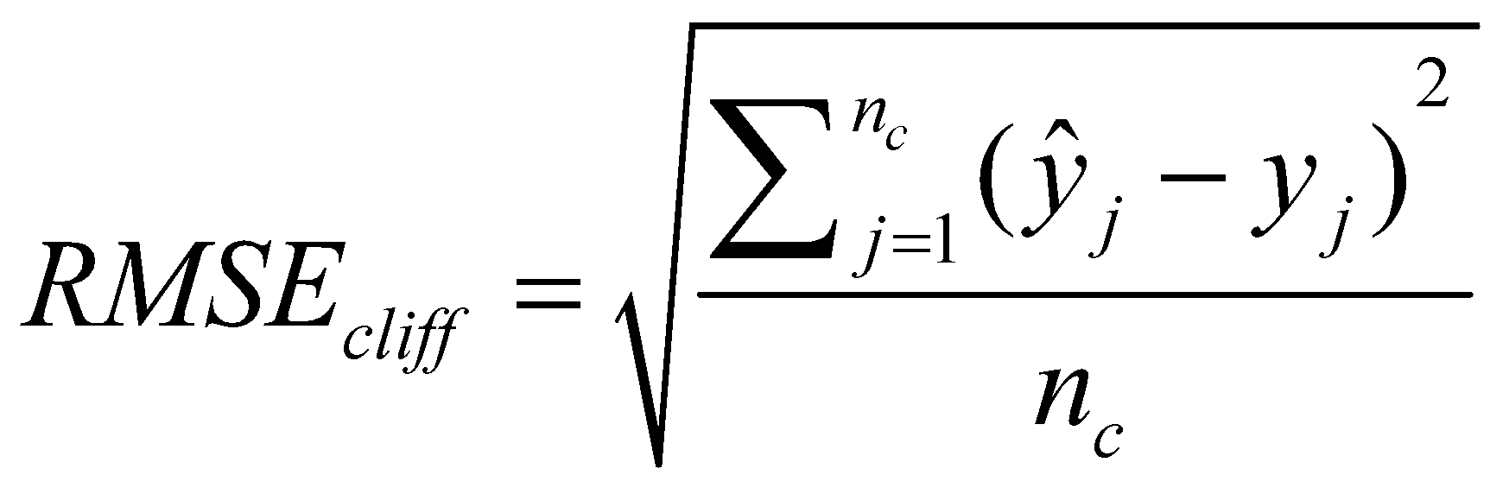 | (2)
where ${\hat{y}}_{j}$is the predicted bioactivity of the j-th activity cliff compound, $y_{j}$ is the corresponding experimental value, and n_{c} represents the total number of activity cliff compounds considered. R² and Q² metrics, or normalized RMSE values were not considered to avoid the introduction of undesired biases related to the different range of the training/test set responses across datasets^{105,106}.

Appendix

Table s3.1 | Presence of highly similar compounds in commercially available libraries. For each library, the number of molecules having at least one highly similar neighbor (determined as having a Tanimoto similarity on ECFPs larger than 90%) was reported, along with the corresponding percentage. ECFPs (1024 bits, radius = 2) were computed with RDKit on canonical SMILES strings, after filtering out duplicates and salts, within KNIME 4.3.3.
Provider and library | no. molecules | no. similar | perc. similar
Asinexª | 572,393 | 76,794 | 13.42%
Specs (10, 20, 50 mg)^{b} | 199,965 | 13,369 | 6.69%
Enamine Advanced^{c} | 604,507 | 173,383 | 28.77%
Enamine Premium^{c} | 40,694 | 18,936 | 46.53%
ª“All screening compounds”, downloaded from https://www.asinex.com/screening-libraries-(all-libraries) on February 2022.
^{b}Downloaded from https://enamine.net/compound-collections/screening-collection/ on February 2022.
^{c}Provided by Specs (https://www.specs.net/) on March 2021.

Table s3.2 | Dataset overview, with receptor class, ChEMBL ID, response type (inhibition [K_{i}] or agonism [EC₅₀]), number of compounds in the train and test set, along with the number of activity cliff compounds in the train and test set.
Target name (ID) | Receptor Class | ChEMBL ID | Type | n train/test | n cliff train/test
Androgen Receptor (AR) | NR | CHEMBL1871 | K_{i} | 525/134 | 126/31
Cannabinoid receptor 1 (CB1) | GPCR | CHEMBL218 | EC₅₀ | 823/208 | 292/75
Coagulation factor X (FX) | Protease | CHEMBL244 | K_{i} | 2476/621 | 1080/270
Delta opioid receptor (DOR) | GPCR | CHEMBL236 | K_{i} | 2077/521 | 772/193
Dopamine D3 receptor (D3R) | GPCR | CHEMBL234 | K_{i} | 2923/734 | 1150/291
Dopamine D4 receptor (D4R) | GPCR | CHEMBL219 | K_{i} | 1485/374 | 572/143
Dopamine transporter (DAT) | Other | CHEMBL238 | K_{i} | 839/213 | 209/54
Dual specificity protein kinase CLK4 | Kinase | CHEMBL4203 | K_{i} | 582/149 | 51/13
Farnesoid X receptor (FXR) | NR | CHEMBL2047 | EC₅₀ | 503/128 | 195/50
Ghrelin receptor (GHSR) | GPCR | CHEMBL4616 | EC₅₀ | 543/139 | 262/68
Glucocorticoid receptor (GR) | NR | CHEMBL2034 | K_{i} | 598/152 | 183/47
Glycogen synthase kinase-3 beta (GSK3) | Kinase | CHEMBL262 | K_{i} | 683/173 | 127/31
Histamine H1 receptor (HRH1) | GPCR | CHEMBL231 | K_{i} | 776/197 | 178/46
Histamine H3 receptor (HRH3) | GPCR | CHEMBL264 | K_{i} | 2288/574 | 865/219
Janus kinase 1 (JAK1) | Kinase | CHEMBL2835 | K_{i} | 489/126 | 36/10
Janus kinase 2 (JAK2) | Kinase | CHEMBL2971 | K_{i} | 779/197 | 95/25
Kappa opioid receptor (KOR) agonism | GPCR | CHEMBL237 | EC₅₀ | 762/193 | 319/81
Kappa opioid receptor (KOR) inhibition | GPCR | CHEMBL237 | K_{i} | 2081/521 | 753/188
μ-opioid receptor (MOR) | GPCR | CHEMBL233 | K_{i} | 2512/630 | 889/222
Orexin receptor 2 (OX2R) | GPCR | CHEMBL4792 | K_{i} | 1174/297 | 610/153
Peroxisome proliferator-activated receptor alpha (PPARα) | NR | CHEMBL239 | EC₅₀ | 1377/344 | 568/141
Peroxisome proliferator-activated receptor delta (PPARδ) | NR | CHEMBL3979 | EC₅₀ | 900/225 | 373/94
Peroxisome proliferator-activated receptor gamma (PPARγ) | NR | CHEMBL235 | EC₅₀ | 1879/470 | 703/178
PI3-kinase p110-alpha subunit (PIK3CA) | Transferase | CHEMBL4005 | K_{i} | 767/193 | 281/70
Serine/threonine-protein kinase PIM1 | Kinase | CHEMBL2147 | K_{i} | 1162/294 | 387/98
Serotonin 1a receptor (5-HT1A) | GPCR | CHEMBL214 | K_{i} | 2651/666 | 917/230
Serotonin transporter (SERT) | Other | CHEMBL228 | K_{i} | 1362/342 | 479/120
Sigma opioid receptor (SOR) | Other | CHEMBL287 | K_{i} | 1061/267 | 371/93
Thrombin | Protease | CHEMBL204 | K_{i} | 2201/553 | 790/199
Tyrosine-protein kinase ABL1 | Kinase | CHEMBL1862 | K_{i} | 633/161 | 202/51
Table s3.3 | Activity cliff definitions across different studies.
Descriptor | Similarity | Potency difference | Study
MACCs | Tanimoto coeff. of 0.85 | 2-fold | Bajorath group. Future Med. Chem. 7, 1565-1579 (2015);  F1000Res, 2 (2013).
ECFPs | Tanimoto coeff. of 0.55 | 2-fold | Bajorath group. Future Med. Chem. 7, 1565-1579 (2015);  F1000Res, 2 (2013).
MMP | Substructure match | 2-fold | Bajorath group. Molecular informatics. 35, 181-191 (2016);  Future Med. Chem. 7, 1565-1579 (2015);  F1000Res, 2 (2013);  J. Chem. Inf. Model. 52, 1138–1145 (2012).
MMP | Substructure match | 1 or 2-fold | Pérez-Benito et al. J. Chem. Theory Comput. 15, 1884–1895 (2019).
Several 2D and 3D, including MACCS | Several similarity measures between 0.8 - 0.95 | 1 or 2-fold | Bajorath group. J. Chem. Inf. Model. 52, 670–677 (2012).
Maximum common substructure | 50% of common substructure atoms | 1-fold | Jiménez-Luna. J. Chem. Inf. Model. 62, 274–283 (2022).
Physicochemical properties | 50% of max SALI score | - | Seebeck et al. ChemMedChem, 6, 1630-1639 (2011).
MACCs, ECFP, TARIS, ROCS, Pharmacophore | SALI score | Variable | Medina-Franco et al. J. Chem. Inf. Model. 49, 477-491 (2009).
AP descriptor | Dice similarity of 0.7 | Custom metric | Sheridan et al. J. Chem. Inf. Model. 60, 1969-1982 (2020).

Table s3.4 | Dataset overview, with number of compounds in the train and test set, the number of activity cliff compounds, the mean number of activity cliff ‘partners’ per activity cliff compound, the number of activity cliff compounds with all activity cliff ‘partners’ in the test set, and the mean maximal substructure/scaffold/SMILES similarity of all test activity cliff compounds to the train set.
Target  ID | n train/test | n cliff train/test | Mean cliff partners | All cliff partners  in test | Mean max. similarity  test cliff to train
AR | 525/134 | 126/31 | 1.66 | 3 | 0.78 / 0.89 / 0.96
CB1 | 823/208 | 292/75 | 2.25 | 3 | 0.81 / 0.92 / 0.96
FX | 2476/621 | 1080/270 | 3.25 | 29 | 0.83 / 0.94 / 0.96
DOR | 2077/521 | 772/193 | 2.91 | 23 | 0.83 / 0.92 / 0.96
D3R | 2923/734 | 1150/291 | 2.73 | 24 | 0.81 / 0.95 / 0.95
D4R | 1485/374 | 572/143 | 2.68 | 12 | 0.79 / 0.95 / 0.95
DAT | 839/213 | 209/54 | 1.73 | 11 | 0.75 / 0.90 / 0.92
CLK4 | 582/149 | 51/13 | 1.25 | 0 | 0.67 / 0.93 / 0.92
FXR | 503/128 | 195/50 | 2.96 | 2 | 0.81 / 0.94 / 0.97
GHSR | 543/139 | 262/68 | 5.51 | 0 | 0.82 / 0.94 / 0.96
GR | 598/152 | 183/47 | 2.64 | 9 | 0.80 / 0.92 / 0.95
GSK3 | 683/173 | 127/31 | 1.59 | 3 | 0.78 / 0.92 / 0.93
HRH1 | 776/197 | 178/46 | 1.75 | 9 | 0.77 / 0.90 / 0.93
HRH3 | 2288/574 | 865/219 | 2.82 | 17 | 0.81 / 0.96 / 0.95
JAK1 | 489/126 | 36/10 | 1.43 | 0 | 0.82 / 0.91 / 0.96
JAK2 | 779/197 | 95/25 | 2.3 | 1 | 0.77 / 0.95 / 0.94
KOR (a) | 762/193 | 319/81 | 4.43 | 4 | 0.84 / 0.92 / 0.96
KOR (i) | 2081/521 | 753/188 | 2.99 | 15 | 0.83 / 0.92 / 0.96
MOR | 2512/630 | 889/222 | 3.71 | 11 | 0.79 / 0.95 / 0.96
OX2R | 1174/297 | 610/153 | 2.37 | 15 | 0.84 / 0.92 / 0.96
PPARα | 1377/344 | 568/141 | 2.84 | 6 | 0.83 / 0.93 / 0.96
PPARδ | 900/225 | 373/94 | 2.5 | 18 | 0.83 / 0.93 / 0.96
PPARγ | 1879/470 | 703/178 | 2.18 | 11 | 0.80 / 0.95 / 0.95
PIK3CA | 767/193 | 281/70 | 3.74 | 6 | 0.79 / 0.94 / 0.95
PIM1 | 1162/294 | 387/98 | 2.31 | 21 | 0.82 / 0.94 / 0.95
5-HT1A | 2651/666 | 917/230 | 2.16 | 15 | 0.80 / 0.94 / 0.94
SERT | 1362/342 | 479/120 | 2.27 | 14 | 0.80 / 0.94 / 0.94
SOR | 1061/267 | 371/93 | 2.32 | 17 | 0.83 / 0.94 / 0.96
Thrombin | 2201/553 | 790/199 | 3.23 | 6 | 0.80 / 0.96 / 0.96
ABL1 | 633/161 | 202/51 | 3.16 | 18 | 0.82 / 0.92 / 0.96
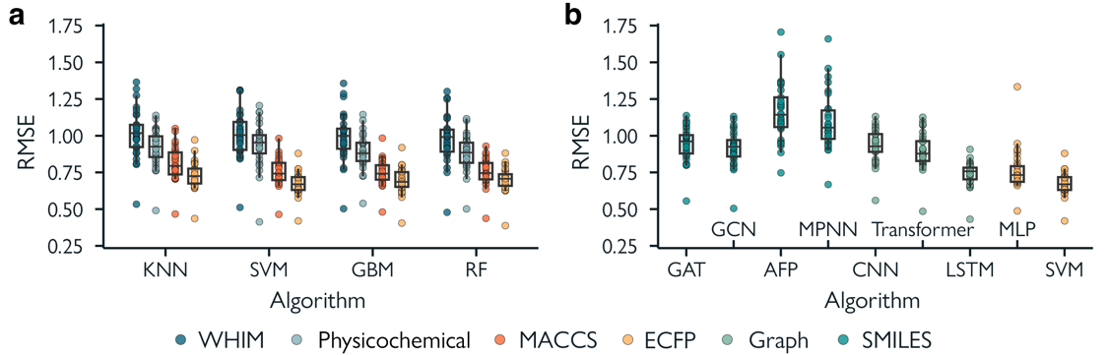Fig. s3.1 | Overall performance of machine learning methods on all targets. a, RMSE using different traditional machine learning algorithms and molecular descriptors. b, RMSE using deep learning methods and unstructured molecular representations.

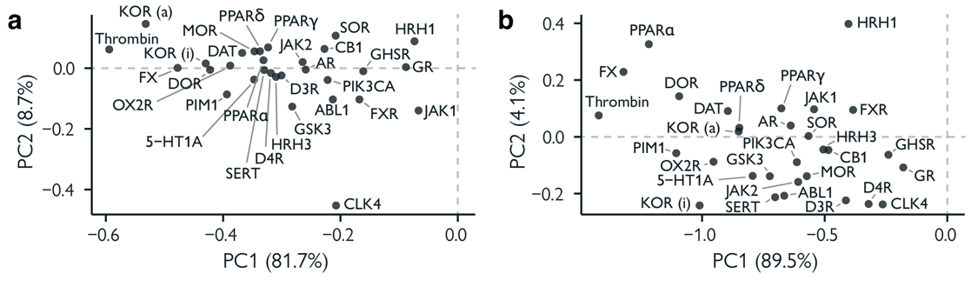
Fig. s3.2 | PCA loadings of all methods. a, Effects of individual data sets (loadings for PC1 and PC2) on the PCA of traditional machine learning methods (see Fig. 3b). b, Effects of individual data sets (loadings for PC1 and PC2) on the PCA of deep learning methods (see Fig. 4b).

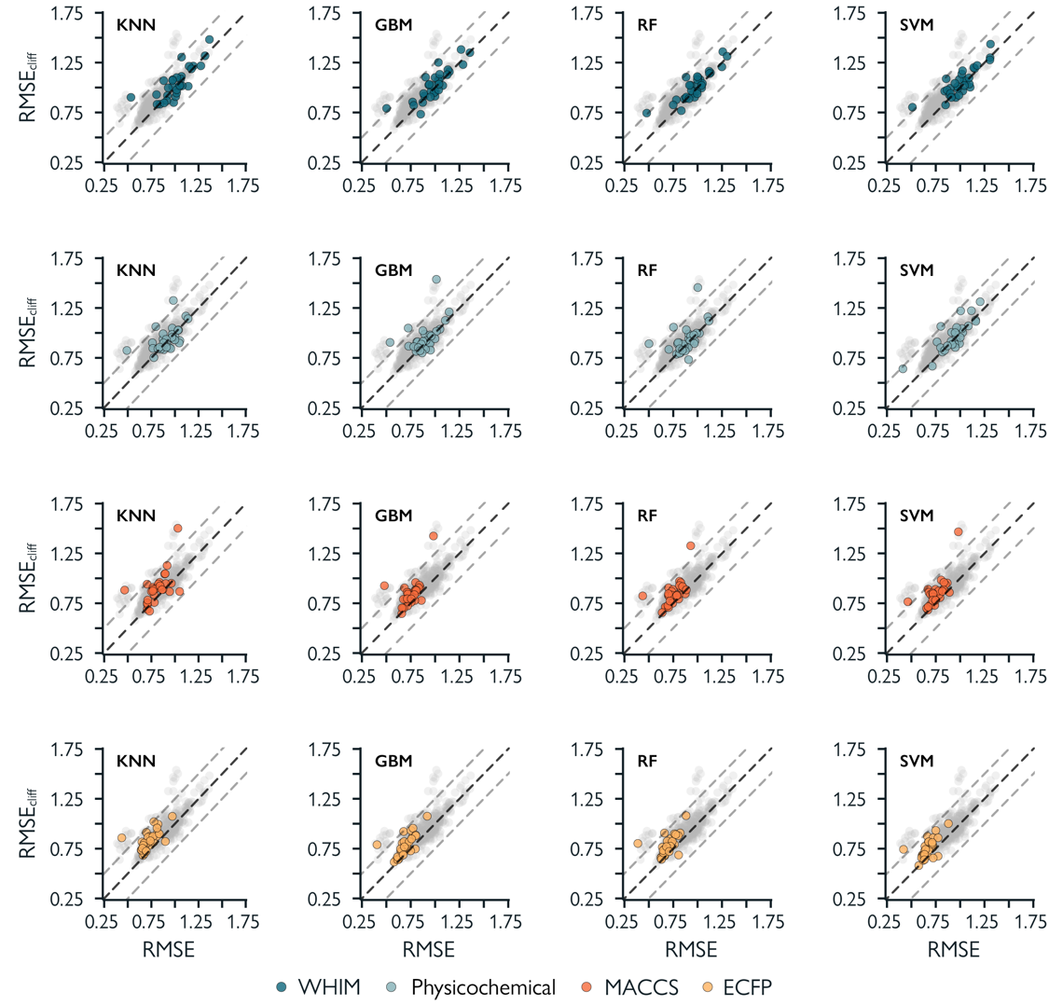
Fig. s3.3 | Relative prediction error of activity cliff compounds. Prediction error on activity cliff compounds compared to all compounds for all traditional machine learning algorithms and molecular descriptor combinations.

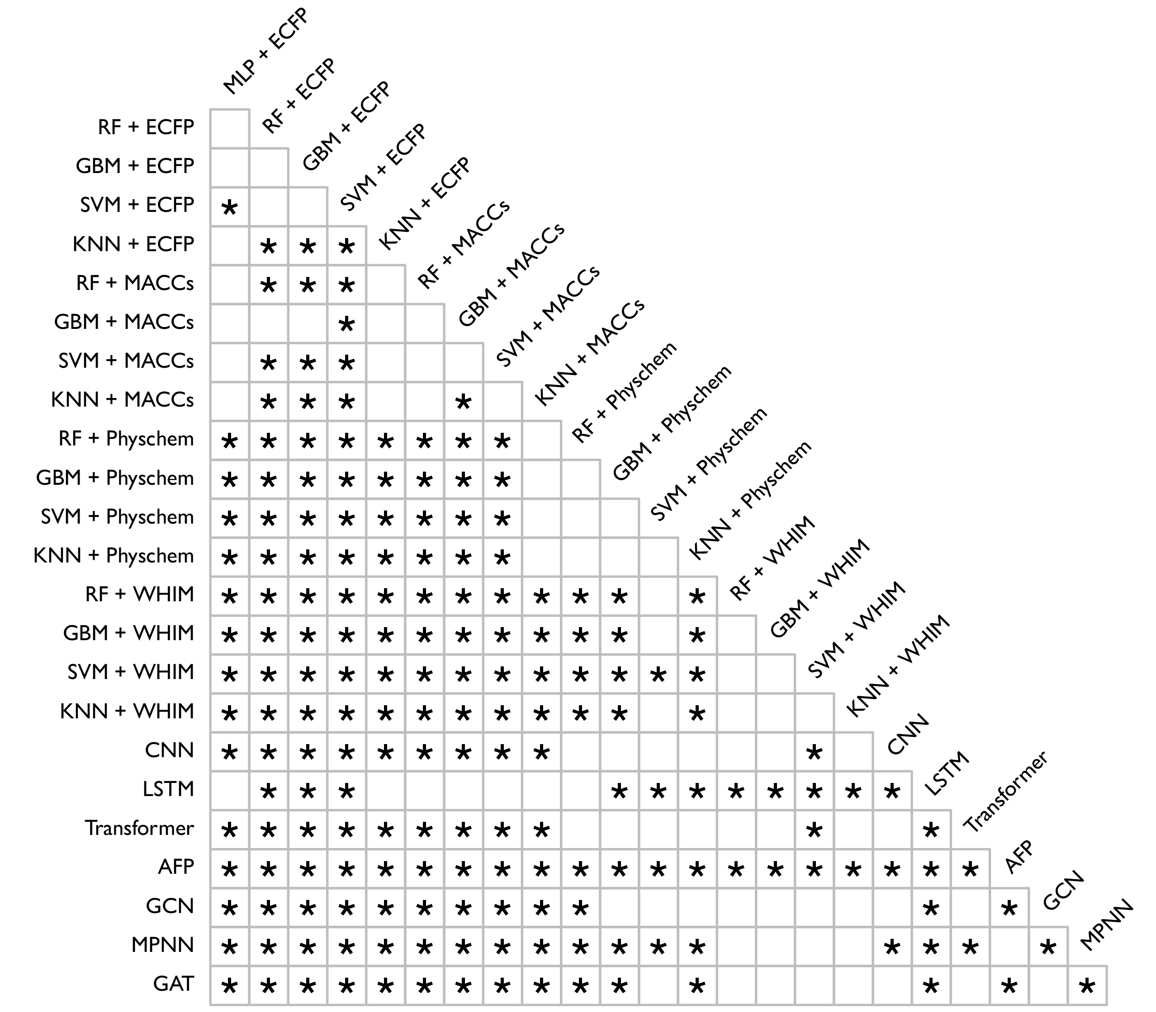
Fig. s3.4 | Statistical differences between the RMSE_{cliff} values obtained by different machine learning strategies. Asterisks indicate statistically significant differences (p < 0.05) between pairs of methods, as obtained by the Wilcoxon rank-sum test (adjusted for false discovery rate using a Benjamini-Hochberg procedure).

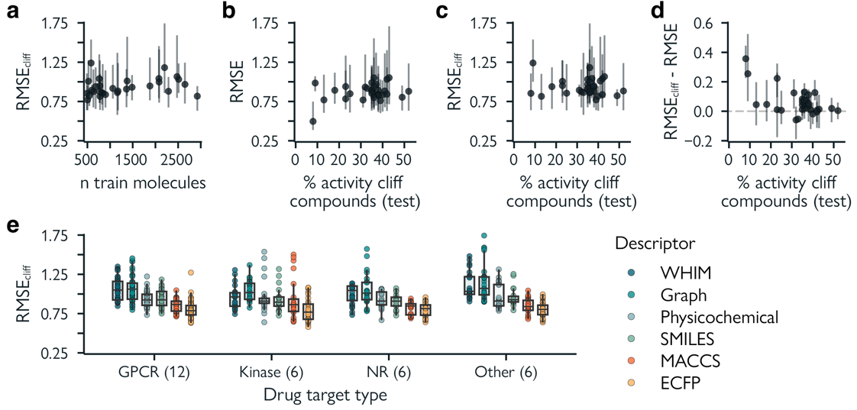
Fig. s3.5 | Confounding effects on RMSE_{cliff}. a. Effect of the number of training molecules. b. Overall model performance (RMSE) for different fractions of activity cliff compounds. Pearson correlation (r) = 0.21. c. Performance on activity cliff compounds for different fractions of activity cliff compounds (RMSE_{cliff}, r=-0.12). d. Difference between RMSE_{cliff} and RMSE for different fractions of activity cliff compounds (r=-0.54). Error bars for a-d indicate the lowest and highest RMSEs. e. The effects of different drug target classes on RMSE_{cliff}. All machine learning strategies are grouped by molecular encoding.

3.8 References

1. Segler, M. H. S., Preuss, M. & Waller, M. P. Planning chemical syntheses with deep neural networks and symbolic AI. Nature 555, 604–610 (2018).
2. Schwaller, P. et al. Molecular Transformer: A Model for Uncertainty-Calibrated Chemical Reaction Prediction. ACS Cent. Sci. 5, 1572–1583 (2019).
3. Coley, C. W., Green, W. H. & Jensen, K. F. Machine Learning in Computer-Aided Synthesis Planning. Acc. Chem. Res. 51, 1281–1289 (2018).
4. Jumper, J. et al. Highly accurate protein structure prediction with AlphaFold. Nature 596, 583–589 (2021).
5. Baek, M. et al. Accurate prediction of protein structures and interactions using a three-track neural network. Science 373, 871–876 (2021).
6. Segler, M. H. S., Kogej, T., Tyrchan, C. & Waller, M. P. Generating Focused Molecule Libraries for Drug Discovery with Recurrent Neural Networks. ACS Cent. Sci. 4, 120–131 (2018).
7. Merk, D., Friedrich, L., Grisoni, F. & Schneider, G. De Novo Design of Bioactive Small Molecules by Artificial Intelligence. Molecular Informatics 37, 1700153 (2018).
8. Yuan, W. et al. Chemical Space Mimicry for Drug Discovery. J. Chem. Inf. Model. 57, 875–882 (2017).
9. De Almeida, A. F., Moreira, R. & Rodrigues, T. Synthetic organic chemistry driven by artificial intelligence. Nat Rev Chem 3, 589–604 (2019).
10. Baskin, I. I., Winkler, D. & Tetko, I. V. A renaissance of neural networks in drug discovery. Expert Opinion on Drug Discovery 11, 785–795 (2016).
11. Chen, H., Engkvist, O., Wang, Y., Olivecrona, M. & Blaschke, T. The rise of deep learning in drug discovery. Drug Discovery Today 23, 1241–1250 (2018).
12. Schmidhuber, J. Deep learning in neural networks: An overview. Neural Networks 61, 85–117 (2015).
13. LeCun, Y., Bengio, Y. & Hinton, G. Deep learning. Nature 521, 436–444 (2015).
14. Atz, K., Grisoni, F. & Schneider, G. Geometric Deep Learning on Molecular Representations. arXiv:2107.12375 [physics, q-bio] (2021).
15. Jiang, D. et al. Could graph neural networks learn better molecular representation for drug discovery? A comparison study of descriptor-based and graph-based models. J Cheminform 13, 12 (2021).
16. Yang, K. et al. Analyzing Learned Molecular Representations for Property Prediction. J. Chem. Inf. Model. 59, 3370–3388 (2019).
17. Valsecchi, C. et al. Predicting molecular activity on nuclear receptors by multitask neural networks. Journal of Chemometrics 36, e3325 (2022).
18. Johnson, M. & Maggiora, G. Concepts and Applications of Molecular Similarity. (Wiley, 1991).
19. Stumpfe, D., Hu, H. & Bajorath, J. Advances in exploring activity cliffs. J Comput Aided Mol Des 34, 929–942 (2020).
20. Maggiora, G. M. On Outliers and Activity CliffsWhy QSAR Often Disappoints. J. Chem. Inf. Model. 46, 1535–1535 (2006).
21. Stumpfe, D. & Bajorath, J. Exploring Activity Cliffs in Medicinal Chemistry. J. Med. Chem. 55, 2932–2942 (2012).
22. Dimova, D., Heikamp, K., Stumpfe, D. & Bajorath, J. Do Medicinal Chemists Learn from Activity Cliffs? A Systematic Evaluation of Cliff Progression in Evolving Compound Data Sets. J. Med. Chem. 56, 3339–3345 (2013).
23. Wedlake, A. J. et al. Structural Alerts and Random Forest Models in a Consensus Approach for Receptor Binding Molecular Initiating Events. Chem. Res. Toxicol. 33, 388–401 (2020).
24. Hu, Y. & Bajorath, J. Extending the Activity Cliff Concept: Structural Categorization of Activity Cliffs and Systematic Identification of Different Types of Cliffs in the ChEMBL Database. J. Chem. Inf. Model. 52, 1806–1811 (2012).
25. Cruz-Monteagudo, M. et al. Activity cliffs in drug discovery: Dr Jekyll or Mr Hyde? Drug Discovery Today 19, 1069–1080 (2014).
26. Stumpfe, D., Hu, Y., Dimova, D. & Bajorath, J. Recent Progress in Understanding Activity Cliffs and Their Utility in Medicinal Chemistry. J. Med. Chem. 57, 18–28 (2014).
27. Bajorath, J. et al. Navigating structure–activity landscapes. Drug Discovery Today 14, 698–705 (2009).
28. Todeschini, R., Consonni, V., Mannhold, R., Kubinyi, H. & Folkers, G. Molecular Descriptors for Chemoinformatics. (Wiley, 2009).
29. Wu, Z. et al. MoleculeNet: a benchmark for molecular machine learning. Chem. Sci. 9, 513–530 (2018).
30. Feinberg, E. N. et al. PotentialNet for Molecular Property Prediction. ACS Cent. Sci. 4, 1520–1530 (2018).
31. Hu, W. et al. Open Graph Benchmark: Datasets for Machine Learning on Graphs. in Advances in Neural Information Processing Systems vol. 33 22118–22133 (Curran Associates, Inc., 2020).
32. Stanley, M. et al. FS-Mol: A Few-Shot Learning Dataset of Molecules.
33. Raji, I. D., Bender, E. M., Paullada, A., Denton, E. & Hanna, A. AI and the Everything in the Whole Wide World Benchmark. Preprint at http://arxiv.org/abs/2111.15366 (2021).
34. Gaulton, A. et al. ChEMBL: a large-scale bioactivity database for drug discovery. Nucleic Acids Research 40, D1100–D1107 (2012).
35. Tiikkainen, P., Bellis, L., Light, Y. & Franke, L. Estimating Error Rates in Bioactivity Databases. J. Chem. Inf. Model. 53, 2499–2505 (2013).
36. Mansouri, K., Grulke, C. M., Richard, A. M., Judson, R. S. & Williams, A. J. An automated curation procedure for addressing chemical errors and inconsistencies in public datasets used in QSAR modelling$. SAR and QSAR in Environmental Research 27, 911–937 (2016).
37. Fourches, D., Muratov, E. & Tropsha, A. Trust, But Verify: On the Importance of Chemical Structure Curation in Cheminformatics and QSAR Modeling Research. J. Chem. Inf. Model. 50, 1189–1204 (2010).
38. Cereto-Massagué, A. et al. Molecular fingerprint similarity search in virtual screening. Methods 71, 58–63 (2015).
39. Rogers, D. & Hahn, M. Extended-Connectivity Fingerprints. J. Chem. Inf. Model. 50, 742–754 (2010).
40. Bemis, G. W. & Murcko, M. A. The Properties of Known Drugs. 1. Molecular Frameworks. J. Med. Chem. 39, 2887–2893 (1996).
41. Yujian, L. & Bo, L. A Normalized Levenshtein Distance Metric. IEEE Transactions on Pattern Analysis and Machine Intelligence 29, 1091–1095 (2007).
42. Hussain, J. & Rea, C. Computationally Efficient Algorithm to Identify Matched Molecular Pairs (MMPs) in Large Data Sets. J. Chem. Inf. Model. 50, 339–348 (2010).
43. Hu, X., Hu, Y., Vogt, M., Stumpfe, D. & Bajorath, J. MMP-Cliffs: Systematic Identification of Activity Cliffs on the Basis of Matched Molecular Pairs. J. Chem. Inf. Model. 52, 1138–1145 (2012).
44. Bajorath, J. Representation and identification of activity cliffs. Expert Opinion on Drug Discovery 12, 879–883 (2017).
45. Puzyn, T., Mostrag-Szlichtyng, A., Gajewicz, A., Skrzyński, M. & Worth, A. P. Investigating the influence of data splitting on the predictive ability of QSAR/QSPR models. Struct Chem 22, 795–804 (2011).
46. Yu, S. X. & Shi, J. Multiclass Spectral Clustering.
47. Stokes, J. M. et al. A Deep Learning Approach to Antibiotic Discovery. Cell 180, 688-702.e13 (2020).
48. Xiong, Z. et al. Pushing the Boundaries of Molecular Representation for Drug Discovery with the Graph Attention Mechanism. J. Med. Chem. 63, 8749–8760 (2020).
49. Chen, C., Ye, W., Zuo, Y., Zheng, C. & Ong, S. P. Graph Networks as a Universal Machine Learning Framework for Molecules and Crystals. Chem. Mater. 31, 3564–3572 (2019).
50. Kearnes, S., McCloskey, K., Berndl, M., Pande, V. & Riley, P. Molecular graph convolutions: moving beyond fingerprints. J Comput Aided Mol Des 30, 595–608 (2016).
51. Weininger, D. SMILES, a chemical language and information system. 1. Introduction to methodology and encoding rules. J. Chem. Inf. Comput. Sci. 28, 31–36 (1988).
52. Kimber, T. B., Gagnebin, M. & Volkamer, A. Maxsmi: Maximizing molecular property prediction performance with confidence estimation using SMILES augmentation and deep learning. Artificial Intelligence in the Life Sciences 1, 100014 (2021).
53. Arús-Pous, J. et al. Randomized SMILES strings improve the quality of molecular generative models. J Cheminform 11, 71 (2019).
54. Bjerrum, E. J. SMILES Enumeration as Data Augmentation for Neural Network Modeling of Molecules. Preprint at https://doi.org/10.48550/arXiv.1703.07076 (2017).
55. Sheridan, R. P. Three Useful Dimensions for Domain Applicability in QSAR Models Using Random Forest. J. Chem. Inf. Model. 52, 814–823 (2012).
56. Guha, R., Dutta, D., Jurs, P. C. & Chen, T. Local Lazy Regression: Making Use of the Neighborhood to Improve QSAR Predictions. J. Chem. Inf. Model. 46, 1836–1847 (2006).
57. Subramanian, G., Ramsundar, B., Pande, V. & Denny, R. A. Computational Modeling of β-Secretase 1 (BACE-1) Inhibitors Using Ligand Based Approaches. J. Chem. Inf. Model. 56, 1936–1949 (2016).
58. Todeschini, R., Ballabio, D., Cassotti, M. & Consonni, V. N3 and BNN: Two New Similarity Based Classification Methods in Comparison with Other Classifiers. J. Chem. Inf. Model. 55, 2365–2374 (2015).
59. Grisoni, F., Merk, D., Byrne, R. & Schneider, G. Scaffold-Hopping from Synthetic Drugs by Holistic Molecular Representation. Sci Rep 8, 16469 (2018).
60. Tetko, I. V. et al. Critical Assessment of QSAR Models of Environmental Toxicity against Tetrahymena pyriformis: Focusing on Applicability Domain and Overfitting by Variable Selection. J. Chem. Inf. Model. 48, 1733–1746 (2008).
61. Zhu, H. et al. Combinatorial QSAR Modeling of Chemical Toxicants Tested against Tetrahymena pyriformis. J. Chem. Inf. Model. 48, 766–784 (2008).
62. de la Vega de León, A. & Bajorath, J. Prediction of Compound Potency Changes in Matched Molecular Pairs Using Support Vector Regression. J. Chem. Inf. Model. 54, 2654–2663 (2014).
63. Sheridan, R. P. et al. Experimental Error, Kurtosis, Activity Cliffs, and Methodology: What Limits the Predictivity of Quantitative Structure–Activity Relationship Models? J. Chem. Inf. Model. 60, 1969–1982 (2020).
64. Cai, C. et al. Transfer Learning for Drug Discovery. J. Med. Chem. 63, 8683–8694 (2020).
65. Moret, M., Grisoni, F., Katzberger, P. & Schneider, G. Perplexity-Based Molecule Ranking and Bias Estimation of Chemical Language Models. J. Chem. Inf. Model. 62, 1199–1206 (2022).
66. Chithrananda, S., Grand, G. & Ramsundar, B. ChemBERTa: Large-Scale Self-Supervised Pretraining for Molecular Property Prediction. Preprint at https://doi.org/10.48550/arXiv.2010.09885 (2020).
67. Gupta, A. et al. Generative Recurrent Networks for De Novo Drug Design. Molecular Informatics 37, 1700111 (2018).
68. Awale, M., Sirockin, F., Stiefl, N. & Reymond, J.-L. Drug Analogs from Fragment-Based Long Short-Term Memory Generative Neural Networks. J. Chem. Inf. Model. 59, 1347–1356 (2019).
69. Hu, W. et al. Strategies for Pre-training Graph Neural Networks. Preprint at https://doi.org/10.48550/arXiv.1905.12265 (2020).
70. Veličković, P. et al. Deep Graph Infomax. Preprint at https://doi.org/10.48550/arXiv.1809.10341 (2018).
71. Hamilton, W. L., Ying, R. & Leskovec, J. Inductive Representation Learning on Large Graphs. Preprint at https://doi.org/10.48550/arXiv.1706.02216 (2018).
72. Wang, H. et al. Evaluating Self-Supervised Learning for Molecular Graph Embeddings. Preprint at https://doi.org/10.48550/arXiv.2206.08005 (2023).
73. Jiménez-Luna, J., Skalic, M. & Weskamp, N. Benchmarking Molecular Feature Attribution Methods with Activity Cliffs. J. Chem. Inf. Model. 62, 274–283 (2022).
74. Kwapien, K. et al. Implications of Additivity and Nonadditivity for Machine Learning and Deep Learning Models in Drug Design. ACS Omega 7, 26573–26581 (2022).
75. Stumpfe, D., Hu, H. & Bajorath, J. Introducing a new category of activity cliffs with chemical modifications at multiple sites and rationalizing contributions of individual substitutions. Bioorganic & Medicinal Chemistry 27, 3605–3612 (2019).
76. Hu, H. & Bajorath, J. Introducing a new category of activity cliffs combining different compound similarity criteria. RSC Med. Chem. 11, 132–141 (2020).
77. Gogishvili, D., Nittinger, E., Margreitter, C. & Tyrchan, C. Nonadditivity in public and inhouse data: implications for drug design. J Cheminform 13, 47 (2021).
78. Vogt, M. Progress with modeling activity landscapes in drug discovery. Expert Opinion on Drug Discovery 13, 605–615 (2018).
79. Fourches, D. & Ash, J. 4D- quantitative structure–activity relationship modeling: making a comeback. Expert Opinion on Drug Discovery 14, 1227–1235 (2019).
80. Zbontar, J., Jing, L., Misra, I., LeCun, Y. & Deny, S. Barlow Twins: Self-Supervised Learning via Redundancy Reduction. Preprint at https://doi.org/10.48550/arXiv.2103.03230 (2021).
81. Husby, J., Bottegoni, G., Kufareva, I., Abagyan, R. & Cavalli, A. Structure-Based Predictions of Activity Cliffs. J. Chem. Inf. Model. 55, 1062–1076 (2015).
82. Wallach, I., Dzamba, M. & Heifets, A. AtomNet: A Deep Convolutional Neural Network for Bioactivity Prediction in Structure-based Drug Discovery. Preprint at https://doi.org/10.48550/arXiv.1510.02855 (2015).
83. Gentile, F. et al. Deep Docking: A Deep Learning Platform for Augmentation of Structure Based Drug Discovery. ACS Cent. Sci. 6, 939–949 (2020).
84. Volkov, M. et al. On the Frustration to Predict Binding Affinities from Protein–Ligand Structures with Deep Neural Networks. J. Med. Chem. 65, 7946–7958 (2022).
85. Sieg, J., Flachsenberg, F. & Rarey, M. In Need of Bias Control: Evaluating Chemical Data for Machine Learning in Structure-Based Virtual Screening. J. Chem. Inf. Model. 59, 947–961 (2019).
86. Chen, L. et al. Hidden bias in the DUD-E dataset leads to misleading performance of deep learning in structure-based virtual screening. PLOS ONE 14, e0220113 (2019).
87. Sheridan, R. P., Culberson, J. C., Joshi, E., Tudor, M. & Karnachi, P. Prediction Accuracy of Production ADMET Models as a Function of Version: Activity Cliffs Rule. J. Chem. Inf. Model. 62, 3275–3280 (2022).
88. Landrum, G. RDKit: Open-source cheminformatics. (2006).
89. Rorabacher, D. B. Statistical treatment for rejection of deviant values: critical values of Dixon’s ‘Q’ parameter and related subrange ratios at the 95% confidence level. Anal. Chem. 63, 139–146 (1991).
90. Durant, J. L., Leland, B. A., Henry, D. R. & Nourse, J. G. Reoptimization of MDL Keys for Use in Drug Discovery. J. Chem. Inf. Comput. Sci. 42, 1273–1280 (2002).
91. Todeschini, R. & Gramatica, P. New 3D Molecular Descriptors: The WHIM theory and QSAR Applications. in 3D QSAR in Drug Design (eds. Kubinyi, H., Folkers, G. & Martin, Y. C.) vol. 2 355–380 (Kluwer Academic Publishers, Dordrecht, 2002).
92. Riniker, S. & Landrum, G. A. Better Informed Distance Geometry: Using What We Know To Improve Conformation Generation. J. Chem. Inf. Model. 55, 2562–2574 (2015).
93. Halgren, T. A. Merck molecular force field. I. Basis, form, scope, parameterization, and performance of MMFF94. Journal of Computational Chemistry 17, 490–519 (1996).
94. Wildman, S. A. & Crippen, G. M. Prediction of Physicochemical Parameters by Atomic Contributions. J. Chem. Inf. Comput. Sci. 39, 868–873 (1999).
95. Bachmann, M. python-Levenshtein.
96. Pedregosa, F. et al. Scikit-learn: Machine Learning in Python. (2012) doi:10.48550/ARXIV.1201.0490.
97. Virtanen, P. et al. SciPy 1.0: fundamental algorithms for scientific computing in Python. Nat Methods 17, 261–272 (2020).
98. Gasteiger, J. & Marsili, M. Iterative partial equalization of orbital electronegativity—a rapid access to atomic charges. Tetrahedron 36, 3219–3228 (1980).
99. Fey, M. & Lenssen, J. E. Fast Graph Representation Learning with PyTorch Geometric. Preprint at http://arxiv.org/abs/1903.02428 (2019).
100. Baek, J., Kang, M. & Hwang, S. J. Accurate Learning of Graph Representations with Graph Multiset Pooling. Preprint at https://doi.org/10.48550/arXiv.2102.11533 (2021).
101. Veličković, P. et al. Graph Attention Networks. Preprint at https://doi.org/10.48550/arXiv.1710.10903 (2018).
102. Brody, S., Alon, U. & Yahav, E. How Attentive are Graph Attention Networks? Preprint at https://doi.org/10.48550/arXiv.2105.14491 (2022).
103. Paszke, A. et al. PyTorch: An Imperative Style, High-Performance Deep Learning Library. in Advances in Neural Information Processing Systems (eds. Wallach, H. et al.) vol. 32 (Curran Associates, Inc., 2019).
104. Kim, S. et al. PubChem 2019 update: improved access to chemical data. Nucleic Acids Research 47, D1102–D1109 (2019).
105. Alexander, D. L. J., Tropsha, A. & Winkler, D. A. Beware of R2: Simple, Unambiguous Assessment of the Prediction Accuracy of QSAR and QSPR Models. J. Chem. Inf. Model. 55, 1316–1322 (2015).
106. Consonni, V., Todeschini, R., Ballabio, D. & Grisoni, F. On the Misleading Use of for QSAR Model Comparison. Molecular Informatics 38, 1800029 (2019).

